Classic Grilled Cheese Sandwich

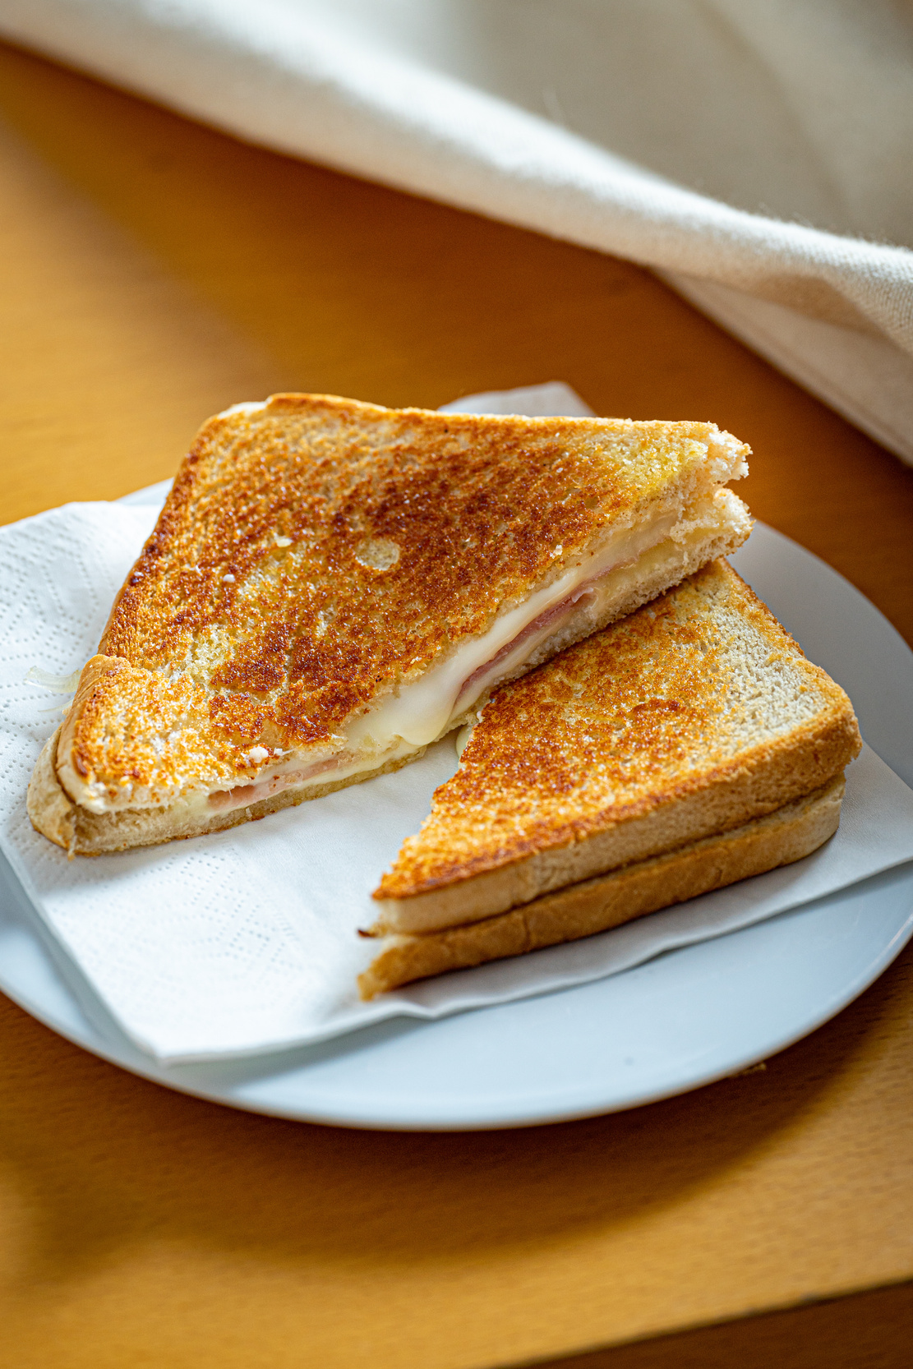

4 slices of bread

4 slices of cheddar cheese

2 tbsp butter, room temperature

Experiment with different types of cheese for a variety of flavors.

Add tomato slices or cooked bacon for an added twist.

Tips:

Instructions:

Lay out the bread slices. Place two slices of cheese between two slices of bread to make each sandwich.

1.

Ingredients:

Spread butter on the outer sides of each sandwich, ensuring to cover the whole surface.

2.

Heat a non-stick skillet over medium heat. Place the sandwiches butter-side down in the skillet. Cook until golden brown, about 3-4 minutes. Butter the top side of the sandwich, then flip it over and cook until the second side is golden brown and the cheese is melted.

3.

Remove the sandwiches from the skillet, let them cool for a minute, then cut diagonally. Serve warm.

4.



Serves: 2

Preparation Time: 5 Minutes

Cooking Time: 15 Minutes

