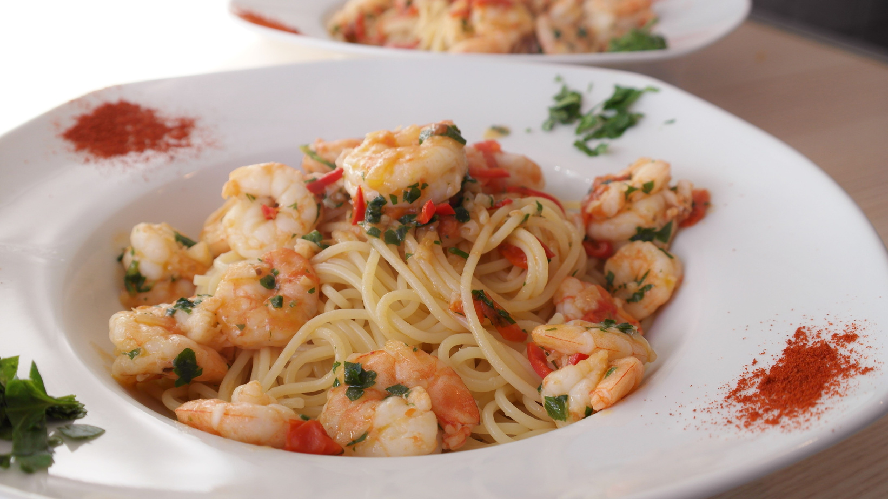

* **Cook the pasta:** Bring a large pot of salted water to a boil. Add the linguine and cook until al dente, according to the package instructions. Drain and set aside.
* **Prepare the shrimp:** Meanwhile, heat the olive oil in a large skillet over medium-high heat. Add the shrimp, season with salt and pepper, and sauté until they turn pink, about 2-3 minutes per side. Remove the shrimp from the skillet and set aside.
* **Make the sauce:** In the same skillet, add the minced garlic and red pepper flakes. Cook until the garlic is fragrant, about 1 minute. Stir in the chicken broth, lemon juice, and lemon zest. Bring the mixture to a simmer and cook for about 5 minutes, or until the sauce has reduced by half.
* **Combine the pasta and shrimp with the sauce:** Return the shrimp to the skillet. Add the cooked pasta and toss to combine, making sure the pasta is well-coated with the sauce.
* **Serve:** Remove the skillet from the heat. Sprinkle with the chopped fresh parsley and grated Parmesan cheese. Serve immediately.

8 oz linguine pasta

2 tbsp olive oil

1 lb large shrimp, peeled and deveined

Salt to taste

Black pepper to taste

1 tbsp minced garlic

1 tsp red pepper flakes

1/2 cup chicken broth

1 cup fresh lemon juice

Zest of 1 lemon

1/2 cup finely chopped fresh parsley

Grated Parmesan cheese for serving

Ingredients

Instructions

Zesty Lemon Garlic Shrimp Pasta

SERVINGS: 4

PREPPING TIME: 15 MIN

COOKING TIME: 20 MIN

*For an extra punch of flavor, add a splash of white wine to the sauce.*

*Feel free to add more vegetables like cherry tomatoes or spinach for added nutrition.*

*Use whole grain pasta for a healthier twist.*

Tips and Variations