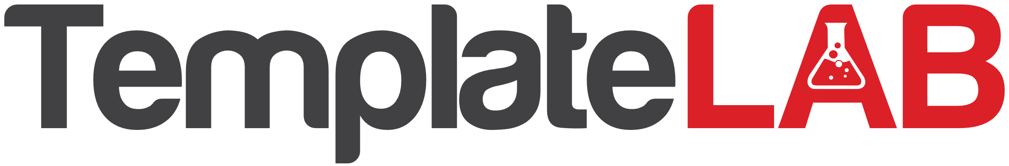

NON-PROFIT PIE CHART

**Programs & Services**

Lorem ipsum dolor sit amet, adipiscing elit. Aenean enim tellus

**Administrative Costs**

Lorem ipsum dolor sit amet, adipiscing elit. Aenean enim tellus

**Fundraising**

Lorem ipsum dolor sit amet, adipiscing elit. Aenean enim tellus

**Research & Development**

Lorem ipsum dolor sit amet, adipiscing elit. Aenean enim tellus



**50%**

**25%**

**10%**

**15%**