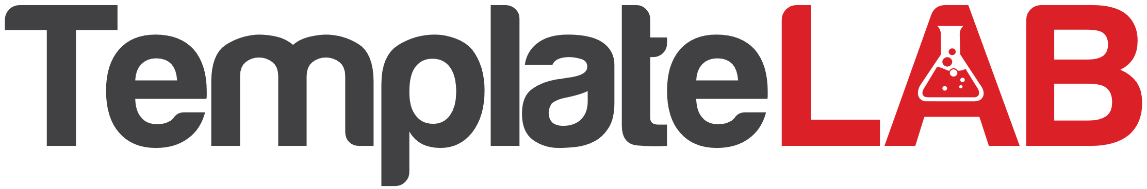

Charity pie chart

Highlighting Our Commitment to Making a Difference: This pie chart provides a transparent overview of how we allocate our funds to various initiatives. Health Programs, taking the largest slice, underscores our dedication to improving health conditions. Education Initiatives, our second priority, reflects our belief in the transformative power of education. Infrastructure Projects highlight our efforts to create sustainable living conditions. While Administration and Fundraising are necessary for our organization's functioning, we strive to keep these costs as low as possible to maximize our impact.