COMPANY NAME
AND LOGO
 | Invoice To:
 | CLIENT'S NAME HERE |  |  | Invoice No
 |  |  |  | 2023-0408
 | 201 Garden Street, 22154 Wyoming
 | clientemail.com |  | Date
 | Phone: 555 1021 205 563 |  | November 15, 2023
 | PRODUCT / SERVICE | QTY / HRS | PRICE / RATE |  | AMOUNT
 | Trendsetting floral designs | 5 | $35.00 |  | $175.00
 | Making decorative displays | 2 | $20.00 |  | $40.00
 | Pink Roses | 6 | $4.50 |  | $27.00
 | Pink Eustoma | 4 | $5.50 |  | $22.00
 | Vase | 1 | $60.00 |  | $60.00
 | White Orchid | 12 | $10.00 |  | $120.00
 | Succulent | 5 | $15.00 |  | $75.00
 | Perfume | 1 | $70.00 |  | $70.00
 | PAYMENT METHOD |  | Sub Total: |  | $589.00
 | Bank: Development Bank for SE |  | Tax: |  | $117.80
 | Acc: 4444 0000 1234 5678 |  | Discount: |  | $52.80
 |  |  | TOTAL: |  | $654.00
 |  |  | 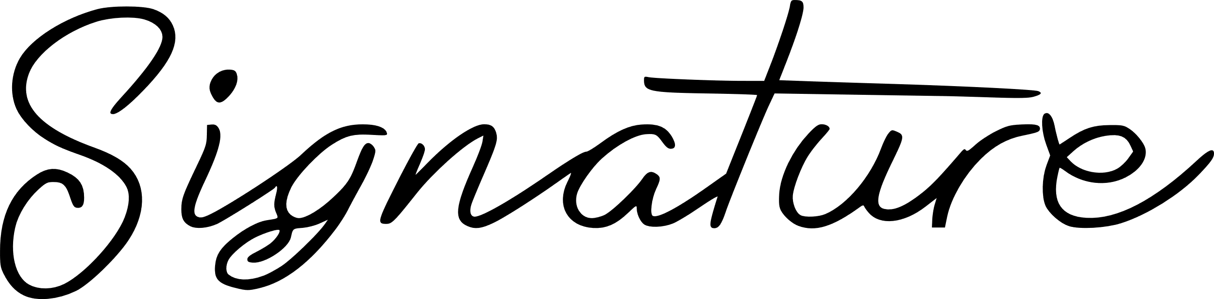
 | Please send payment within 60 days of receiving this invoice.
 |  |  | © TemplateLab.com

