 | JOHN DOE |  |  |  | PLUMBING
 | Premium Plumbing Services
 | 2015 Piping Street |  |  | INVOICE
 | Oklahoma, TH 18524
 | BILL TO |  |  |  | INVOICE NUMBER: |  |  |  | DATE:
 | Michael Marshall |  |  |  | #10025335 |  |  |  | 01/09/2023
 | 207 Client Avenue
 | New Town, BX 21556
 | P: (555) 0000 2205 3325
 | E: michael.marshall@myclient.com
 | SERVICE | ITEM DESCRIPTION |  |  |  |  | QTY | UNIT PRICE | AMOUNT
 |  | Boiler Service  Thorough assessment of your household's boiler. It includes a series of checks, tests, and cleaning. |  |  |  |  | 1 | $140.00 | $140.00
 |  | Cleaning Drains  Water is blasted down the drain at a high pressure and velocity to dislodge the blockage. |  |  |  |  | 1 | $210.00 | $210.00
 |  | Leak Detection and Repair  Use of Ultrasonic leak detectors to locate leaks. Works on the mechanical elimination of leaks. |  |  |  |  | 1 | $200.00 | $200.00
 |  | Toilet Installation  Installing bolts, wax ring, and toilet bowl. Securing the toilet and tank preparation. Installing seat. Leak tests. |  |  |  |  | 1 | $350.00 | $350.00
 |  | Vacuum Unclogging  Using a plunger or vacuum system with a hose to unclog water pipes. Additional chemical treatment afterwards. |  |  |  |  | 3 | $80.00 | $240.00
 |  | Materials  Plastic pipe (10"), 10x Washers, Drain snake insert, Hoses, Screws, Sealing material. |  |  |  |  | 1 | $125.00 | $125.00
 |  |  |  |  |  | SUBTOTAL |  |  | $1,265.00
 |  |  |  |  |  | TAX RATE |  |  | 10%
 |  | TOTAL |  |  |  |  |  | $1,391.50
 |  |  |  |  |  | 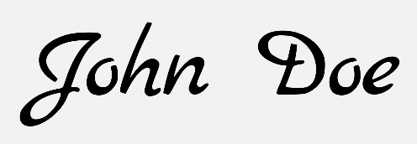
 | Terms & Conditions
 | Payment is due within 15 days
 | Bank Name Here
 | Account #: 01234567890
 | Routing: 099887766554433
 |  |  |  |  |  |  | © TemplateLab.com

