 | Event: Company name 20 Years celebration party |  | INVOICE
 | 4056 Celebration Avenue, 20909 LA
 | February 17th, 2023 (19-23h) |  |  | #1008/23
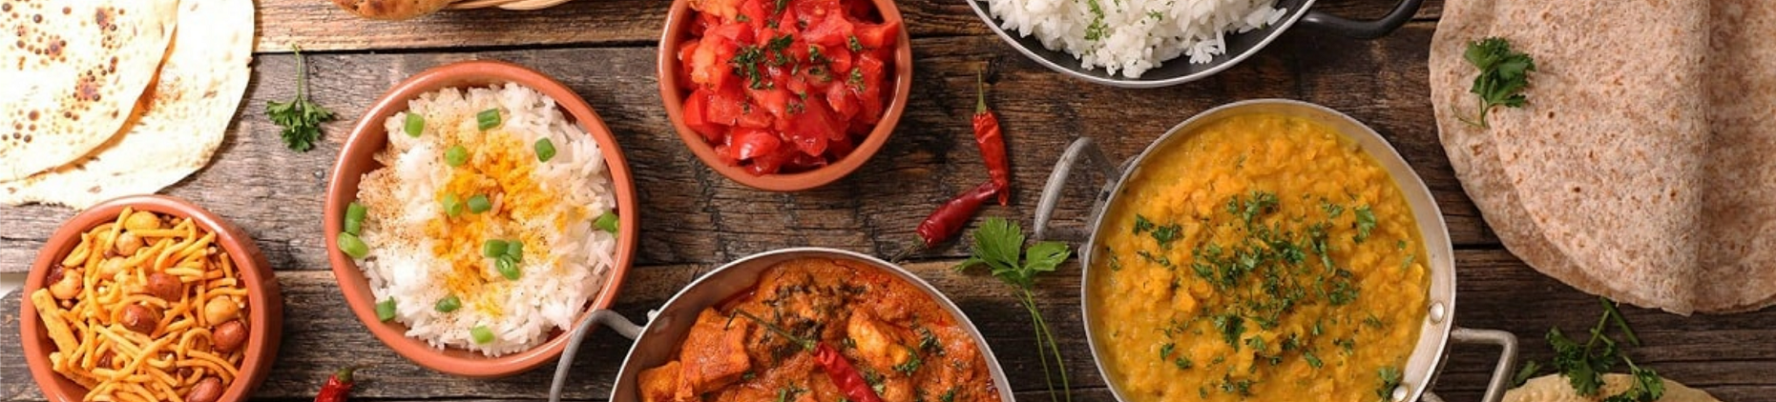
CATERING COMPANY
 | Bill To:
 | Client Name |  | Date of Invoice: | Feb-20-2023
 | Street address |  | Customer ID: | Customer123
 | City, State, Country |  | Agent: | Maria Cane
 | ZIP Code |  | Order #: | 2023/0256
 | Phone |  | Payment due by: | Feb-27-2023
 | Item | Unit cost | Qty/Hr rate | Amount
 | Corporate catering mix 1 | $2,560.00 | 1 | $2,560.00
 | Avocado toast | $6.40 | 50 | $320.00
 | Full silver service | $450.00 | 1 | $450.00
 | Decorations | $180.00 | 3 | $540.00
 | Delivery service | $205.00 | 1 | $205.00
 | Special notes and instructions |  | SUBTOTAL | $4,075.00
 | Your coordination & cooperation throughout all of the company celebration has been great. Thank you for making the whole process stress free! |  | DISCOUNT | -$575.00
 |  |  | (TAX RATE) | 10%
 |  |  | TAX | $350.00
 |  |  | DEPOSIT | $1,000.00
 |  |  | TOTAL | $2,850.00
 |  |  | BANK ACCOUNT DETAILS
 | Thank you for your business! |  | National Bank of Saturn
 |  |  | Acc. #: 1234 0252 0254 3336
 |  |  | Additional info here
 |  |  | © TemplateLab.com
Your Street, City, State, Country, Zip Code
Tel: 1 000-555-0000 | Fax: 1 000-555-1001 | info@yourcompanysite.com | www.yourcompanysite.com

