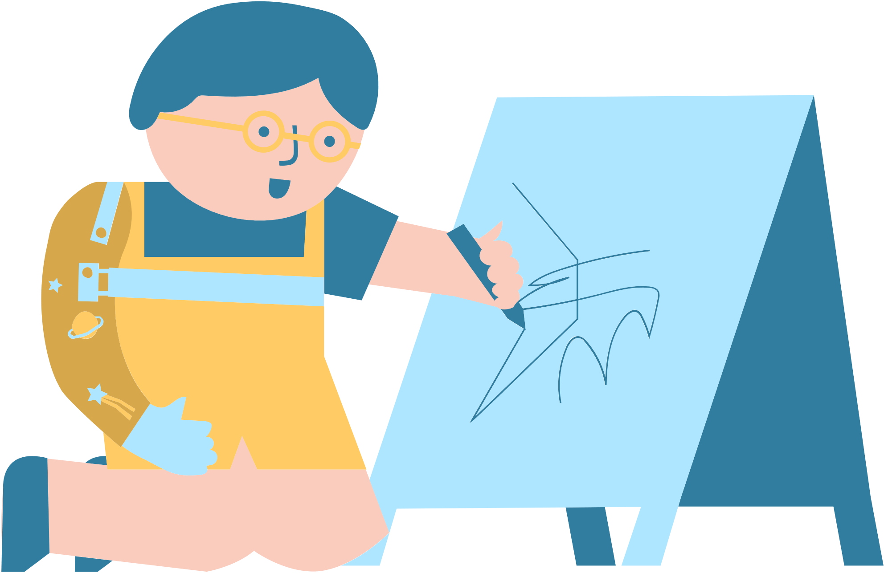

TODDLER NEWSLETTER

MESSAGE FROM THE TEACHER

ACTIVITIES FOR HOME

PICTURE BOOK OF THE MONTH

UPCOMING EVENTS

