THIS WEEK

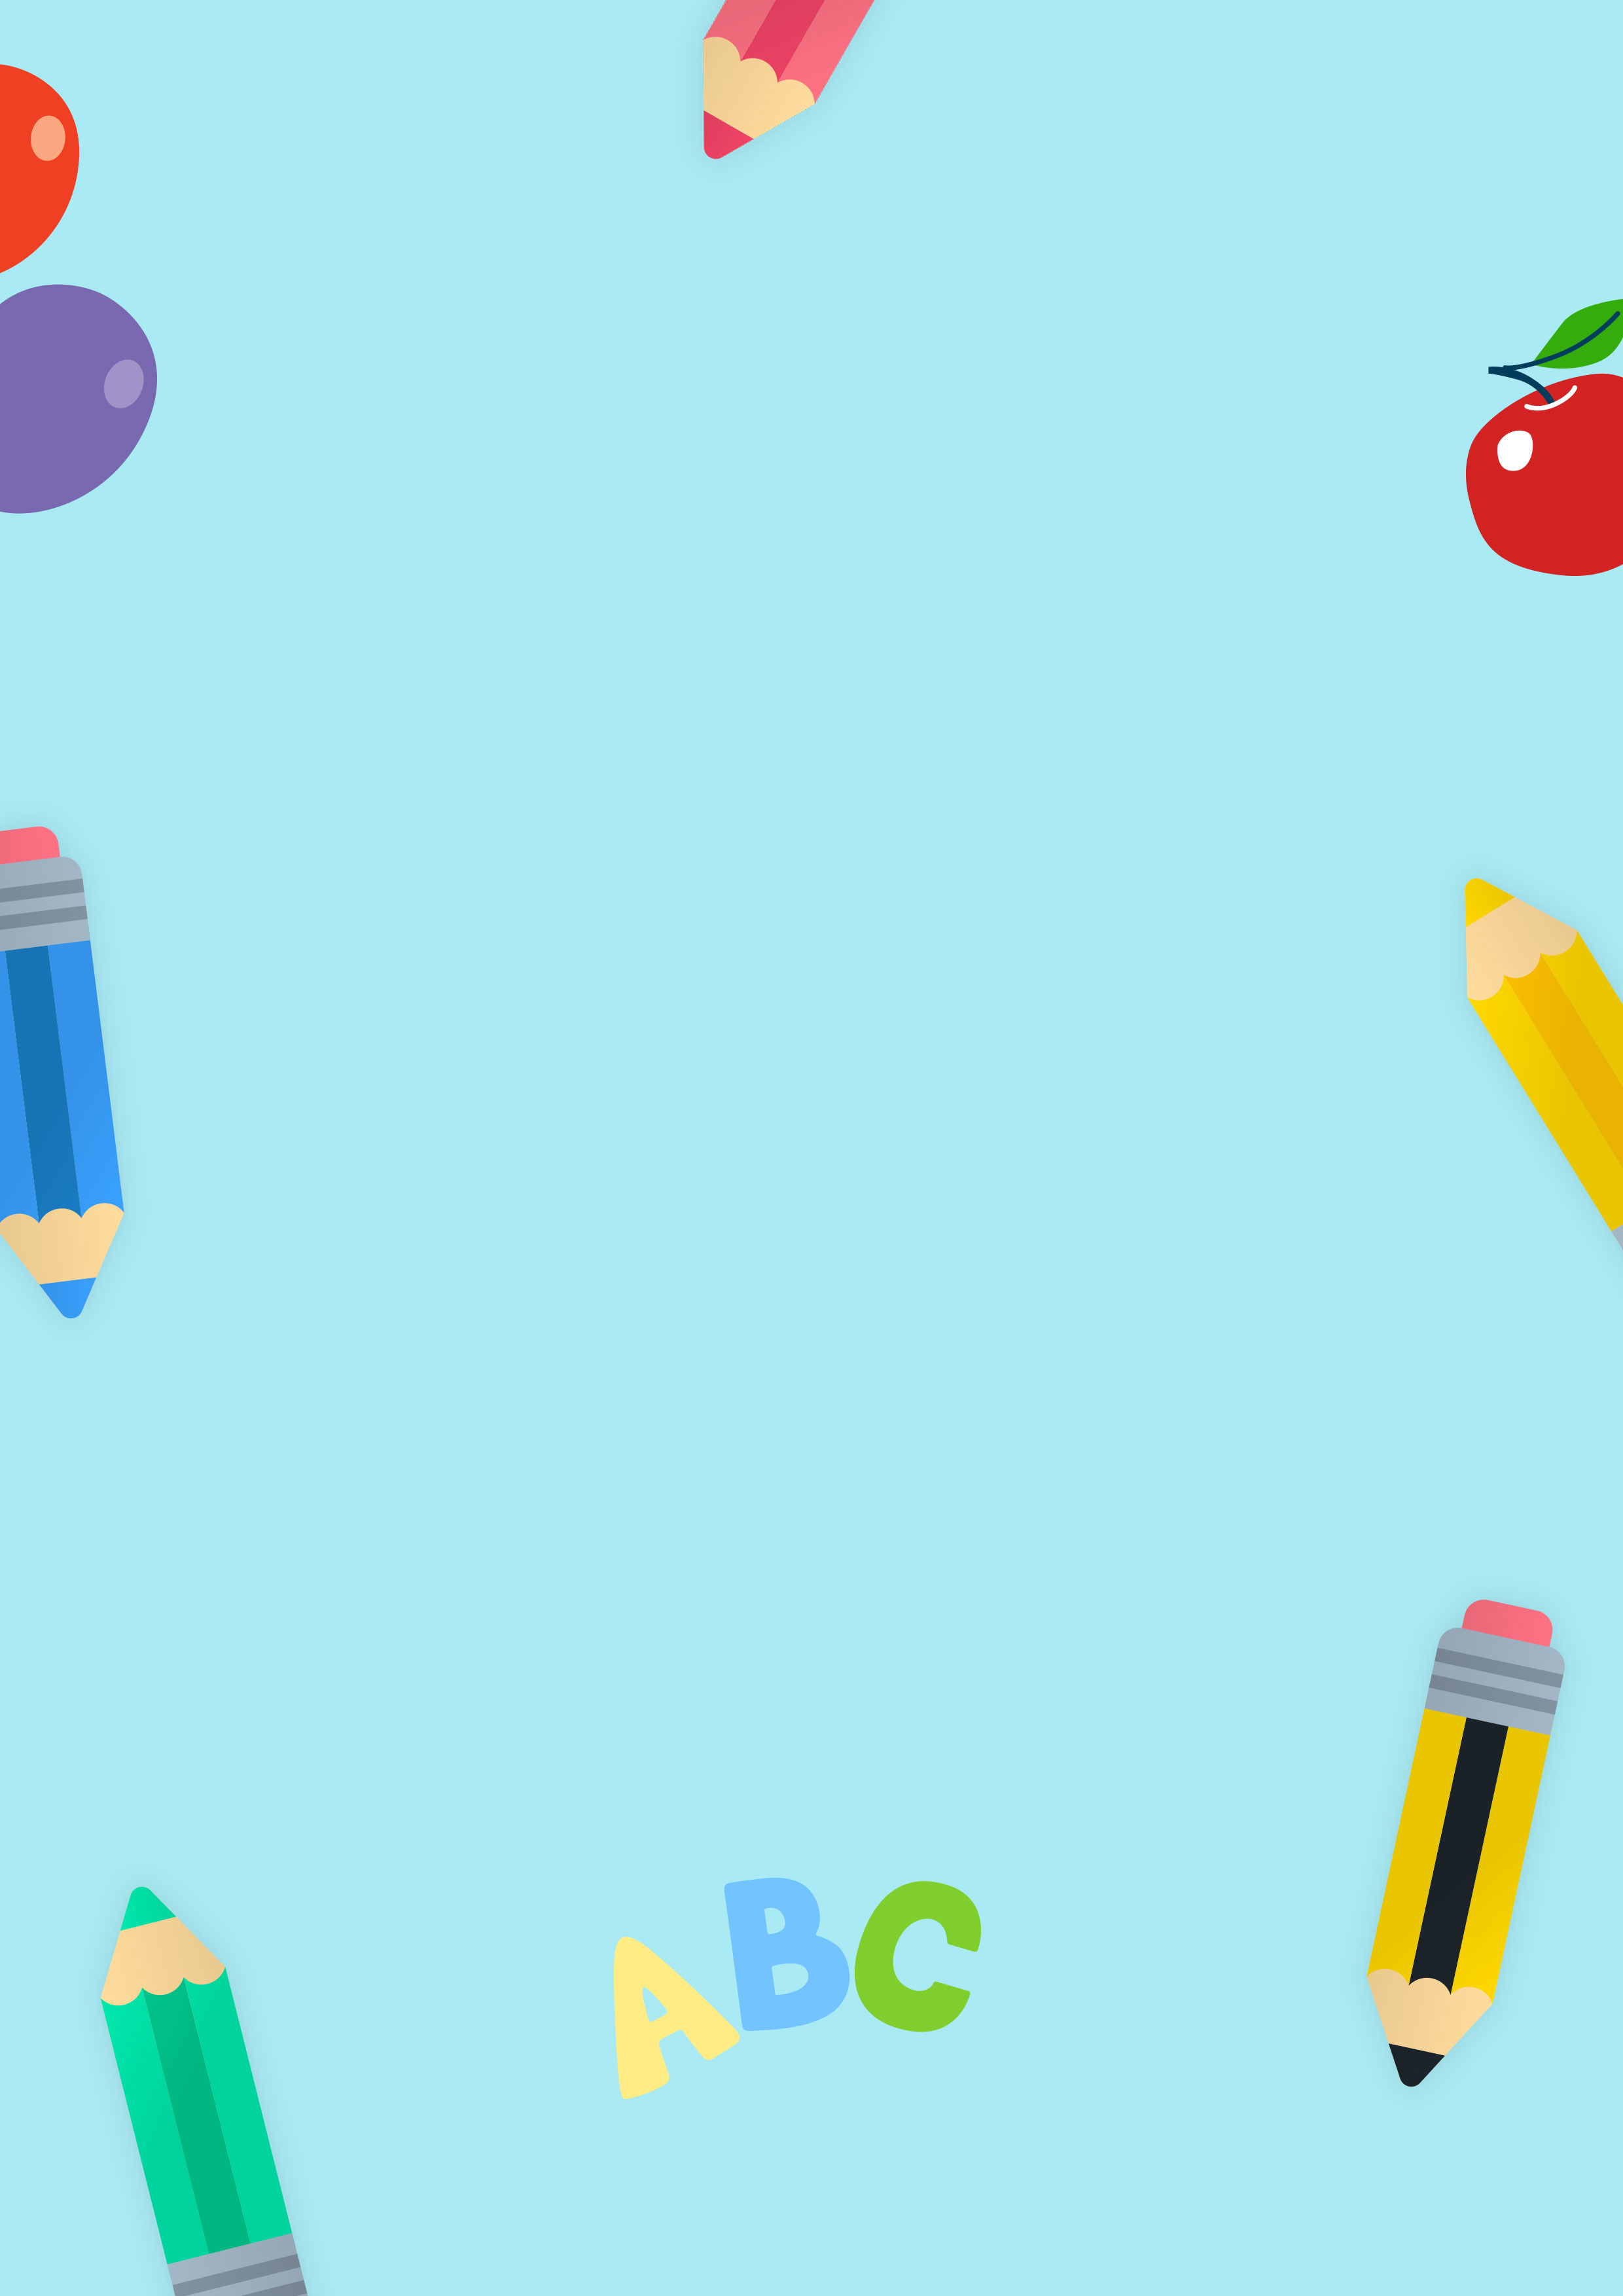

Teacher:



in our class

Reminders

Important Dates

What are we learning?

Date: