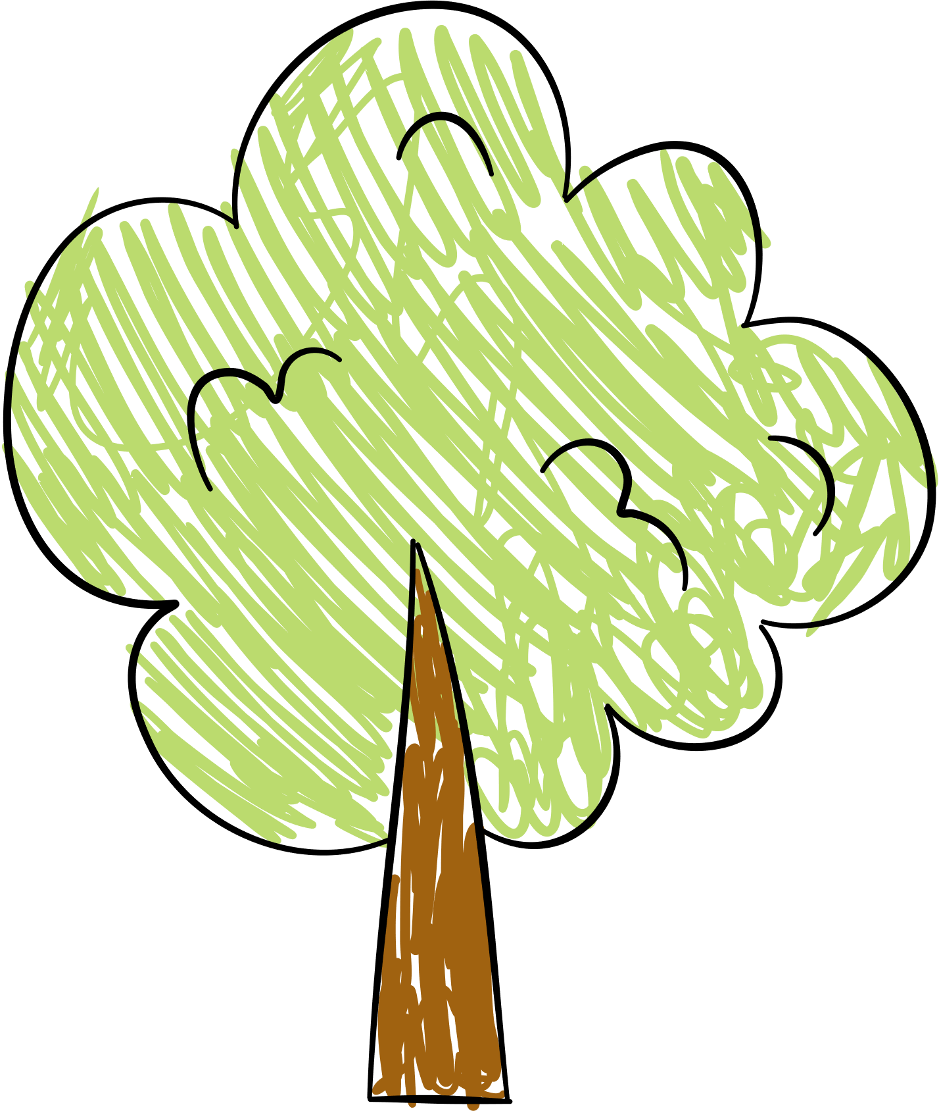

KINDERGARTEN NEWSLETTER

WHAT ARE WE LEARNING?

UPCOMING FIELD TRIPS

ACTIVITIES PARENTS CAN DO AT HOME

DATE :