

Featured Topic

This section could focus on a different educational topic each week or month, providing in-depth coverage and analysis. Topics could include trends in education, policy changes, or innovative teaching methods.

Teacher Spotlight

In this section, you could feature a different teacher each week or month and highlight their accomplishments, hobbies, or fun facts. This is a great way to showcase the diversity and expertise of your teaching staff.

Research Roundup

In this section, you could provide summaries and links to the latest research on education-related topics, such as learning outcomes, teacher retention, or student engagement.

Events & Conferences

This section could provide information on upcoming education-related events and conferences, including dates, locations, and registration details.

Tech Corner

In this section, you could feature news and updates on educational technology tools and platforms, as well as tips and tutorials on how to use them effectively in the classroom.

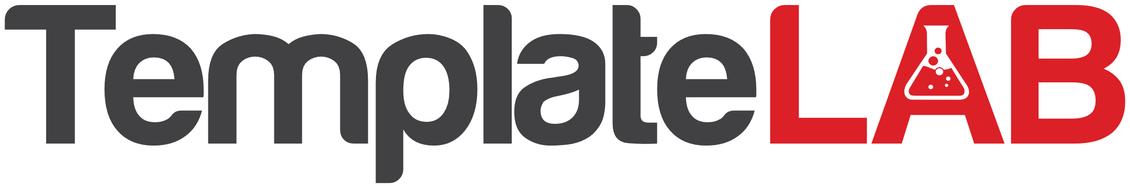

**Education newsletter**