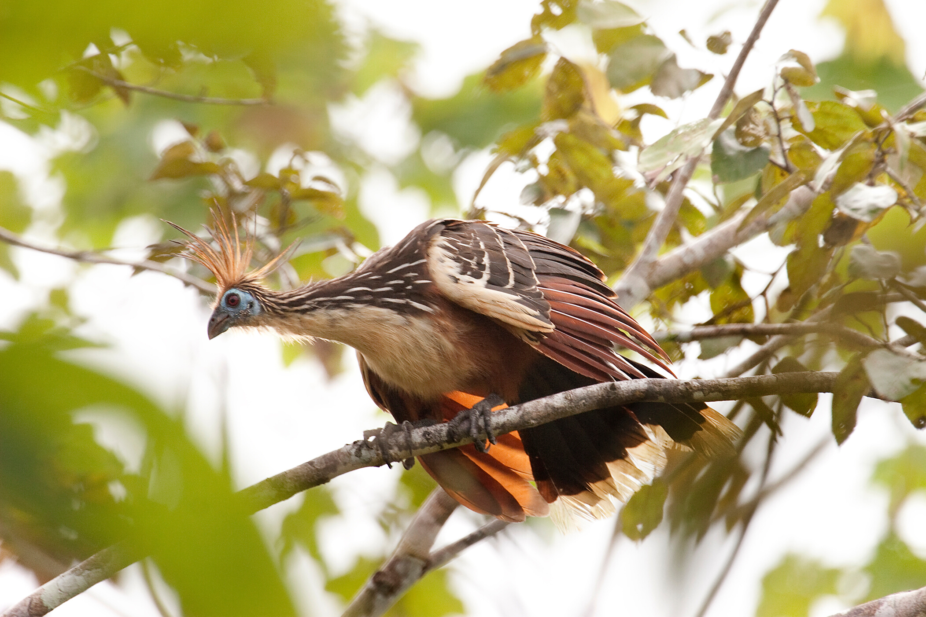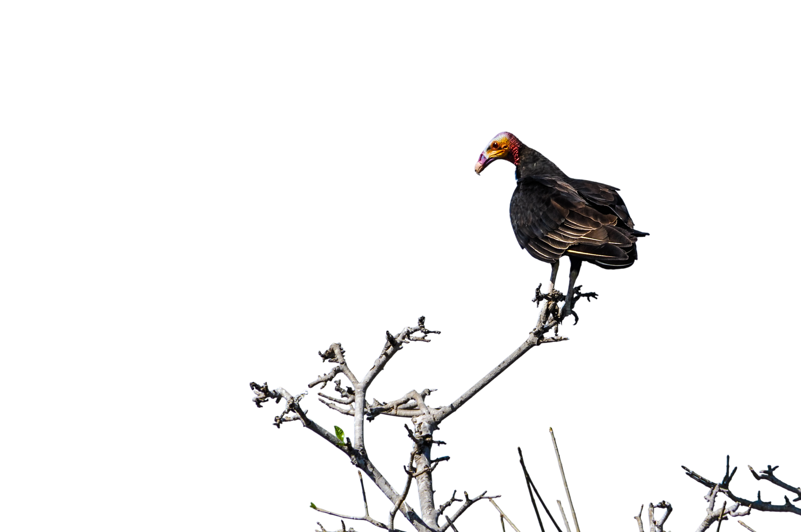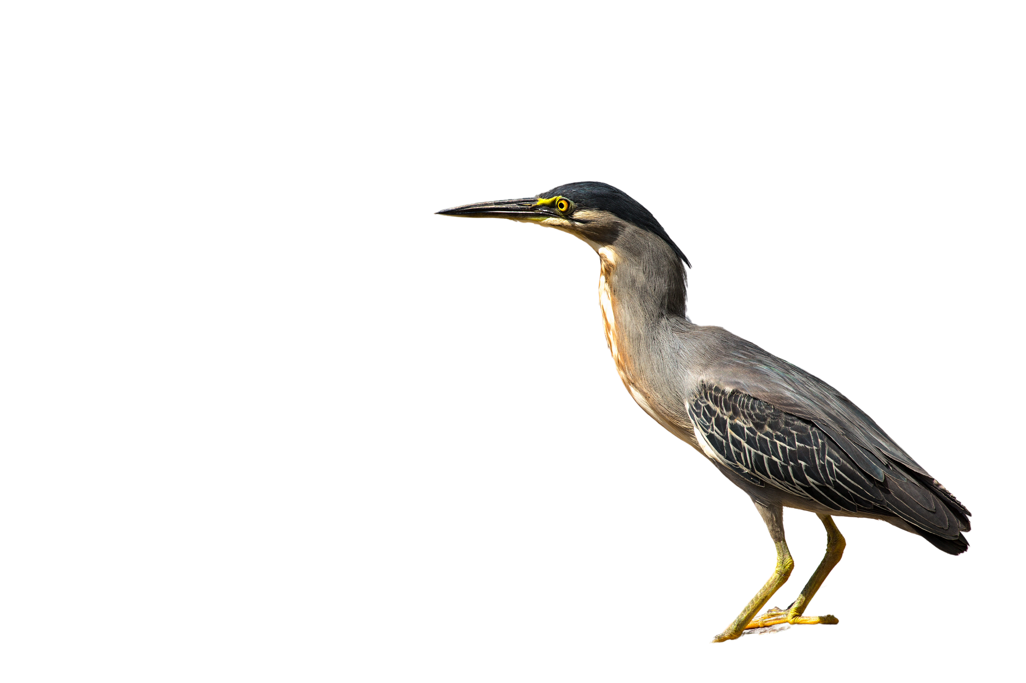

**AUTHORS**

Don't forget the names of the research authors and co-authors. Use full names and include any titles or honorifics the authors may have, as well as the university or research institution they are representing.

**ACKNOWLEDGEMENTS:**

The authors would like to acknowledge the support of the National Science Foundation and the Amazonian Research Institute for their support of this research.

ECOLOGY RESEARCH POSTER

Losing Their Home: The Impact of Deforestation on Bird Diversity in the Amazon Rainforest

INTRODUCTION

Deforestation is a major environmental issue that has significant impacts on biodiversity. The Amazon rainforest is one of the world's most important biodiversity hotspots, but it is also one of the most threatened by deforestation. The aim of this study was to investigate the impact of deforestation on bird diversity in the Amazon rainforest.

METHODS

Bird surveys were conducted in both deforested and undisturbed areas of the Amazon rainforest. The study was conducted over a period of two years and included a total of 60 transects. Each transect was approximately 1 km long and 50 m wide. The bird surveys were conducted twice a day, once in the morning and once in the evening. Birds were identified based on their vocalizations and morphological characteristics. The data collected was analyzed using the Jaccard Similarity Index and the Bray-Curtis Dissimilarity Index.

CONCLUSION

The results of this study indicate that deforestation has a significant impact on bird diversity in the Amazon rainforest. These findings highlight the importance of conservation efforts to protect the remaining undisturbed areas of the Amazon rainforest and to prevent further deforestation.

RESULTS

The results showed that bird diversity was significantly lower in deforested areas compared to undisturbed areas. The Jaccard Similarity Index revealed that bird species composition was significantly different between deforested and undisturbed areas (p < 0.05). The Bray-Curtis Dissimilarity Index showed that deforested areas had a lower bird diversity compared to undisturbed areas (p < 0.05).

**REFERENCES**

* + F. J. Jaksic and C. de los Llanos, "Biodiversity and Conservation in the Neotropics," in Neotropical Biodiversity and Conservation, pp. 3-16, Springer, 2018.
  + S. L. Pimm and J. H. Brown, "Deforestation and Bird Extinctions in Tropical Forest," Conservation Biology, vol. 4, no. 4, pp. 355-364, 1990.
  + B. J. Huebner and R. Greenberg, "Bird Responses to Deforestation in the Amazon Basin," The Auk, vol. 121, no. 2, pp. 359-365, 2004.