

is the registered holder of **1,200** shares transferable only on the books of the **Corporation** by the holder hereof in person or by Attorney upon surrender of this certificate properly endorsed. In Witness Whereof, the said Corporation has caused this certificate to be signed by it duly authorized officers and its Corporate Seal be affixed on 25 August 2028.

Olivia Wilson

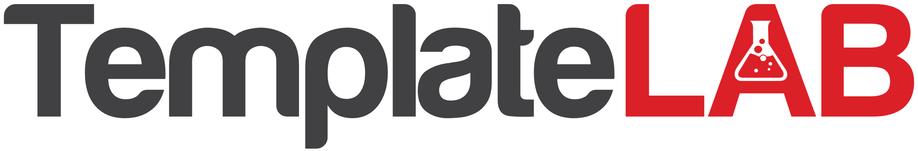

**STOCK CERTIFICATE**

This certifies that

**Jamie Chastain**

**Lorna Alvarado**

President

Secretary