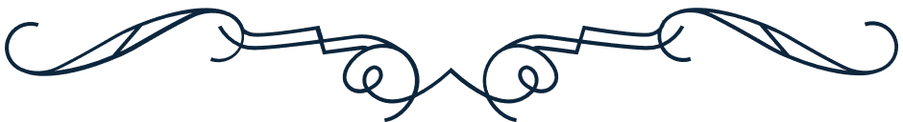

Francisco Andrade

THIS IS TO CERTIFY THAT, ON 15 JULY 2028,

THE INDIVIDUAL KNOWN AS

is the rightful owner of 3,000 stocks at ABC company.

**Kyrie Petrakis**

President

**Frank Marcel**

CEO

Corporate stock certificate

