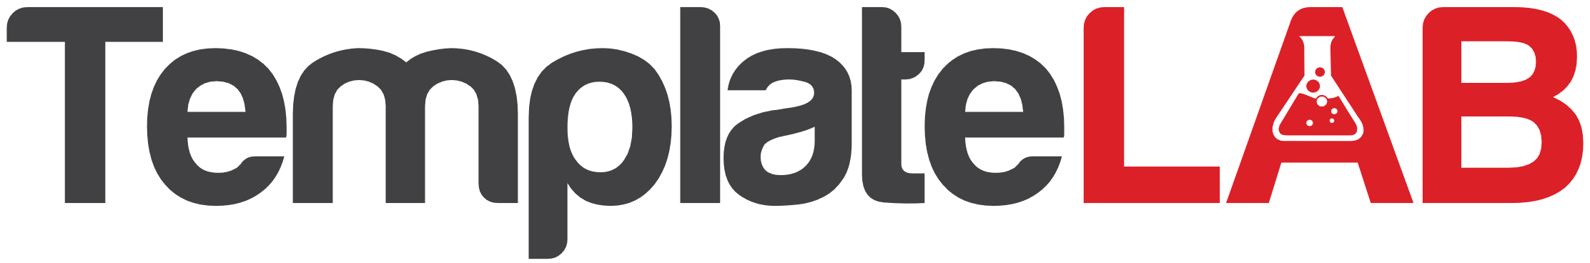

**STOCK CERTIFICATE**

THIS IS TO CERTIFY THAT

signed

signed

IS THE OWNER OF SHARES OF STOCK

OF

ON THIS DAY OF IN THE YEAR

AT