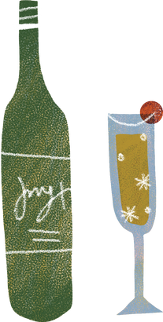

**WINE**

**Definition**

**Sentence**

**Synonums**

**Picture**

A drink made from fermented graphs and therefore counting as a serving of fruits. Improves the taste of many foods and the personalities of many friends.

drink, burgundy, booze, vino, claret

My parent love wines.

**Frayer model vocabulary**