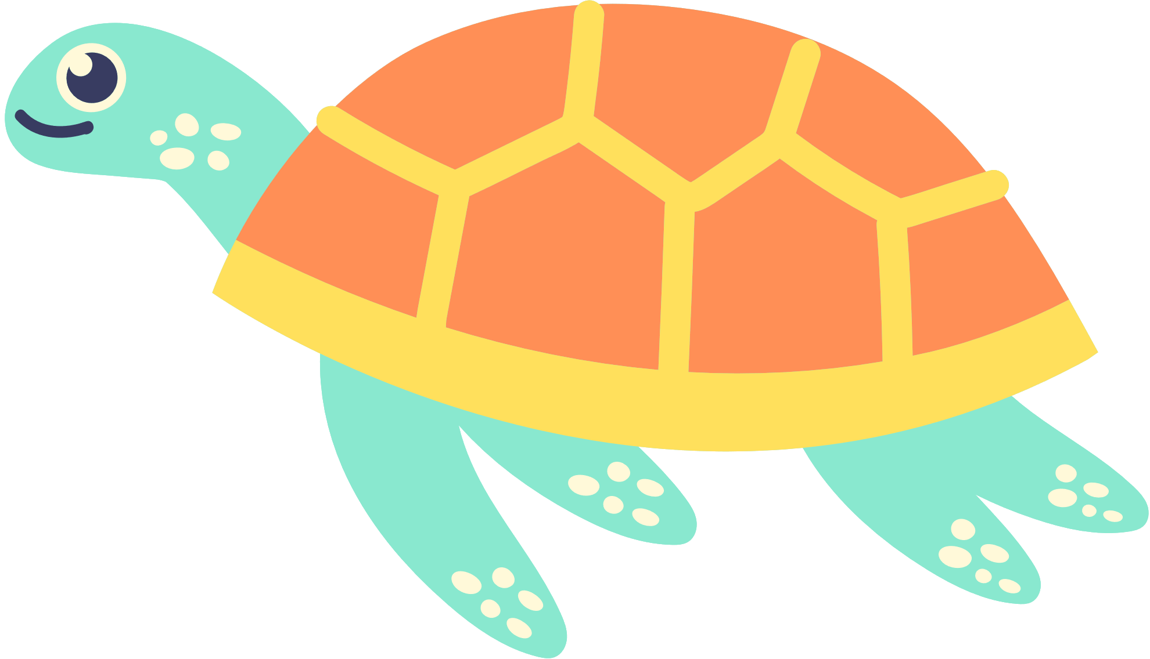

Definition

Examples

Characteristics

Non-examples

TURTLE

A reptilian animal with a hard shell on its back

* + Can pull its head and legs back inside its shell
  + Can live a long time
  + Is cold-blooded
  + Myrtle at the Aquarium
  + Snapping Turtle
  + Sea Turtle
  + Lizard
  + Snake
  + Alligator
  + Fish



FRAYER MODEL VOCABULARY