Frayer model template

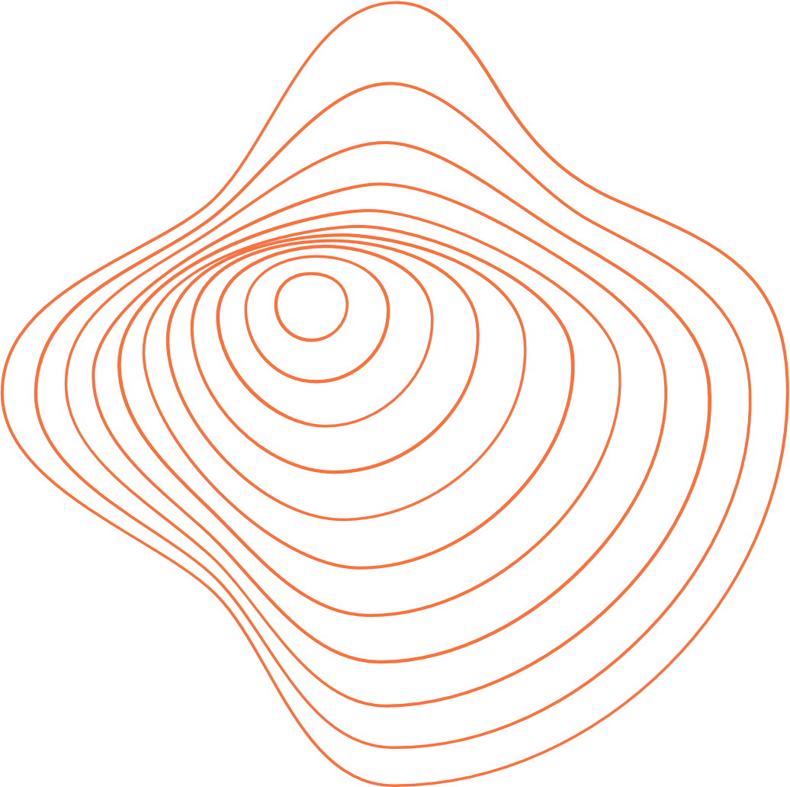

DEFINITION

CHARACTERISTICS

EXAMPLES



NON-EXAMPLES

WORD