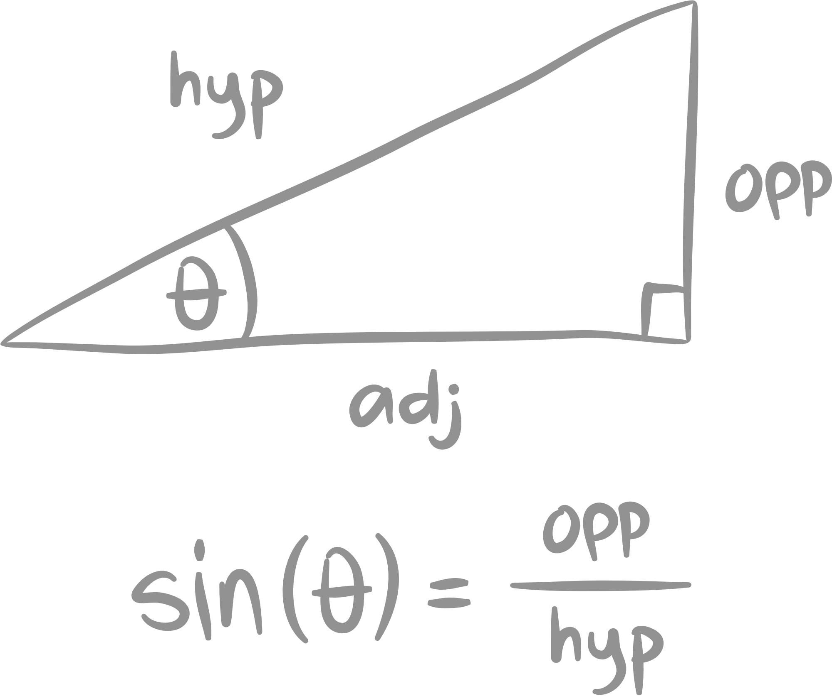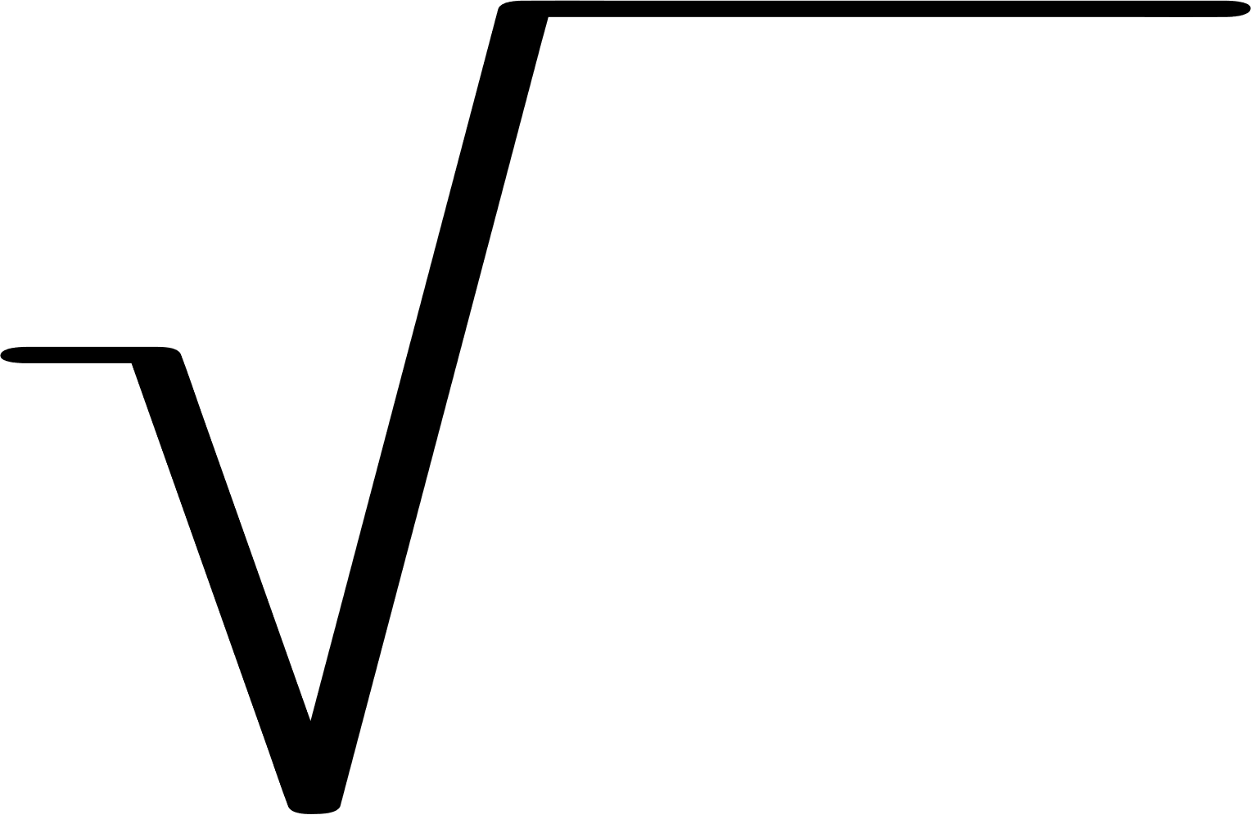

4



9



FRAYER MODEL FOR MATH

THINGS IT HAS TO HAVE/BE

EXAMPLES

THINGS IT MIGHT HAVE/BE

THINGS IT CAN'T HAVE/BE

- The numbers

- Square root

- Represented by two equal factors

- Positive

- Negative

- Decimal

- Fraction

16

25

- Negative

PERFECT SQUARE

