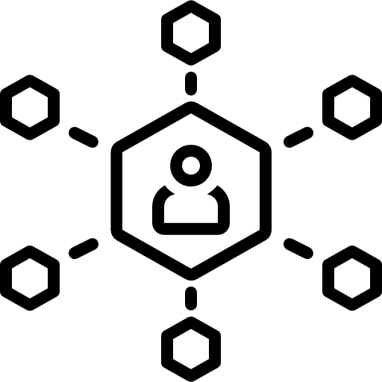

A graphic organizer used to simplify concepts for students

DEFINITION

The key topic is witten in the center and students fill the other parts as per their understanding of key concepts

CHARACTERISTICS

This activity

EXAMPLES

An outline, vocabulary flash cards

NON-EXAMPLES

FRAYER MODEL DIAGRAM