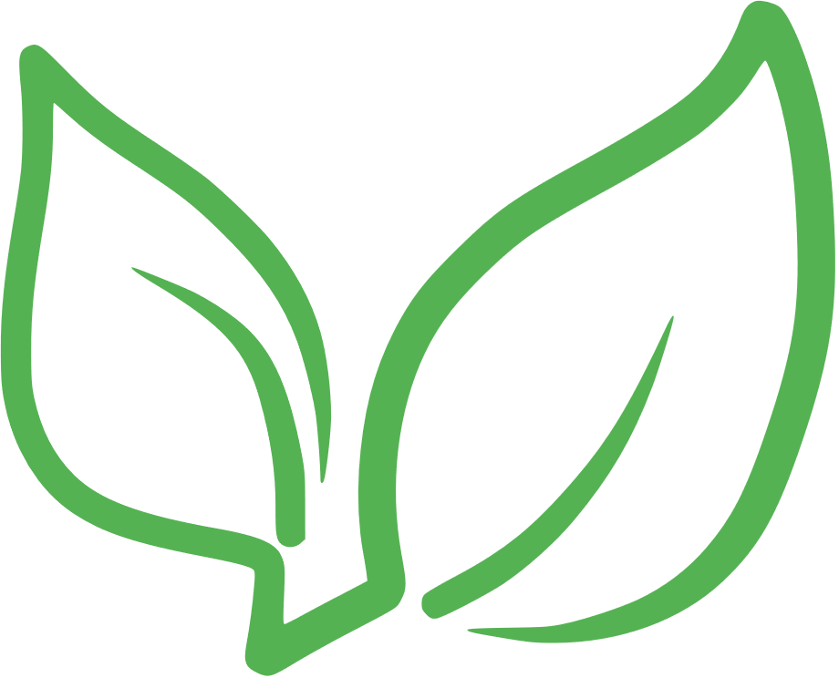

VEGAN GROCERY LIST

nutritional yeast

CONDIMENTS

& SPICES

garlic

ginger

basil

thyme

cinnamon

curry powder

stevia

agave nectar

maple syrup

soy sauce

hummus

oils

HIGH-FAT FOODS

avocado

coconut

olives

chickpeas

BEANS & LEGUMES

lentils

black beans

pinto beans

peas

navy beans

kidney beans

tofu

tempeh

edamame

soy milk

almonds

NUTS & SEEDS

walnuts

pine nuts

hazel nuts

chia seeds

flax seeds

pumpkin seeds

sesame seeds

hemp seeds

quinoa

WHOLE GRAINS

barley

wild rice

brown rice

popcorn

buckwheat

whole-grain bread

whole-grain pasta

spinach or kale

VEGETABLES

cauliflower

carrots

beets

celery

onions

zucchini

cucumbers

bell peppers

sweet potatoes

berries

FRUITS

melons

pitted fruits

apples

bananas

citrus