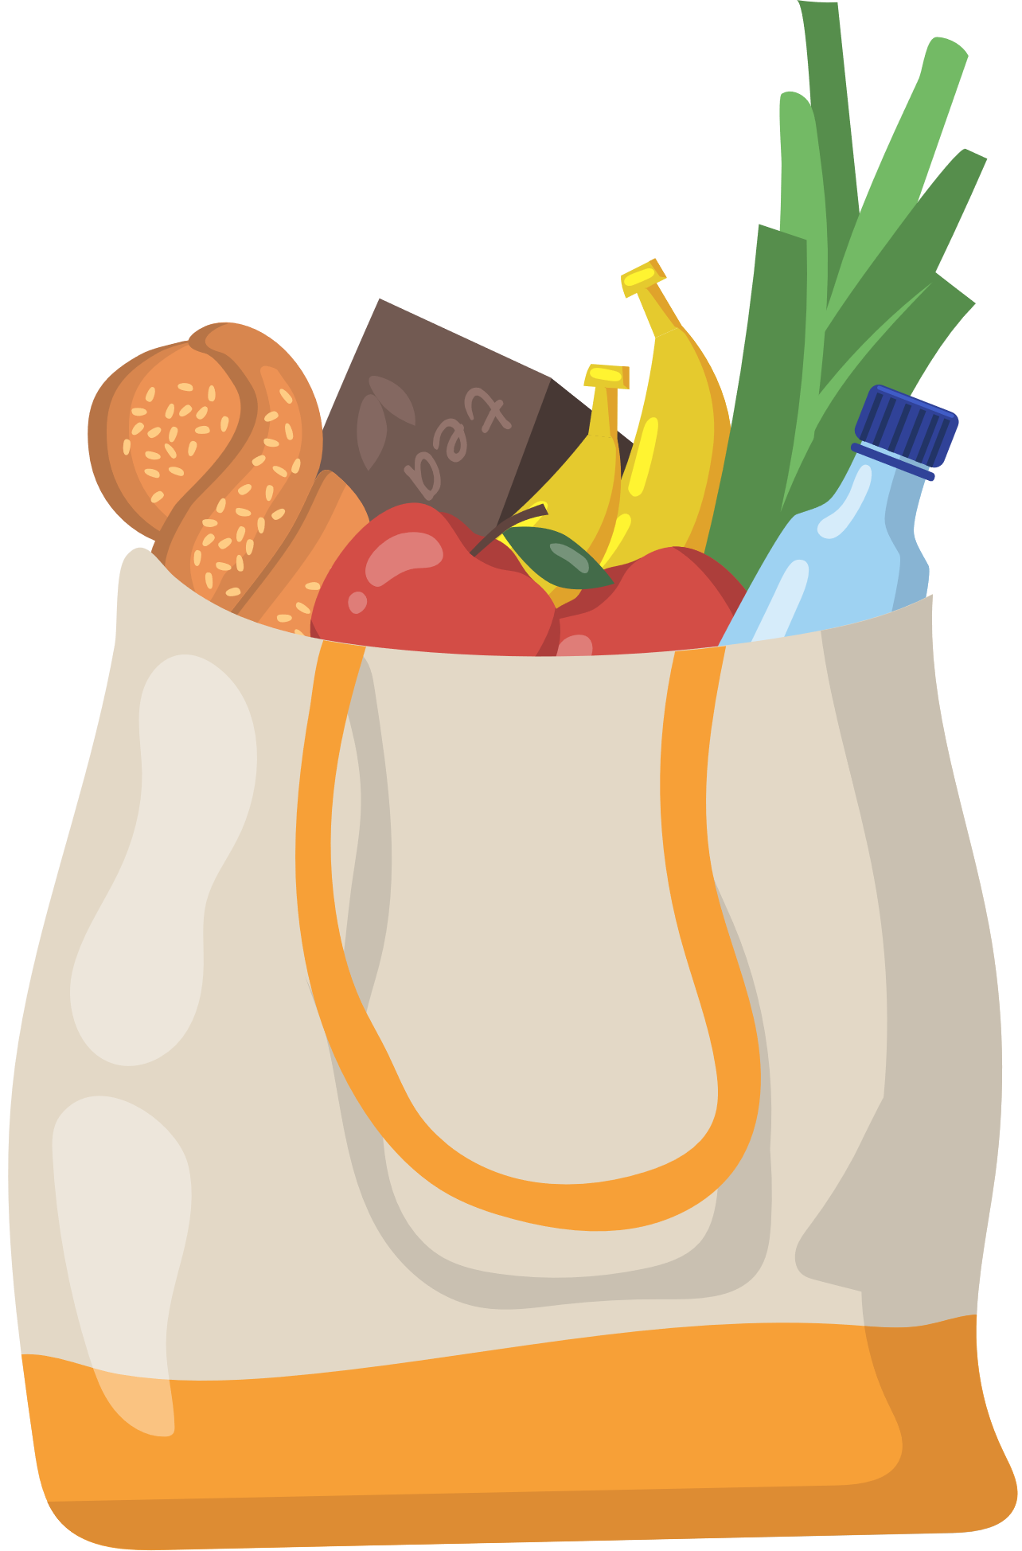­­

applesauce



Cans & Jars

baked beans



black beans



broth



bouillon cubes



canned fruit



canned vegatables



carrots



chili



corn



creamed corn



jam/jelly



mushrooms



olives(green)



olives(black)



shortening



pasta



pasta sauce



peanut butter



pickles



pie filling



soup



MASTER GROCERY LIST

batteries



Misc. items

charcoal



greeting card



light bulbs



bath soap



Personal care

bug repellant



conditioner



cotton swabs



deodorant



facial tissue



hair spray



hand soap



lip care



lotion



makeup



mouthwash



razors



shampoo



shaving cream



sunscreen



toilet tissue



toothbrush



toothpaste



air freshener



Cleaning

bleach



dish soap



fabric softener



floor cleaner



glass spray



laundry soap



polish



sponges



vacuum bags



dishwashing liquid



beer



Drinks

champagne



wine



coffee



soft drinks



energy drinks



juice



tea



bbq sause



Sauces & Condiments

catsup



cocktail sauce



cooking spray



honey



horseradish



hot sauce



lemon juice



mayonnaise



mustard



olive oil



relish



salad dressing



salsa



soy sauce



steak sauce



sweet & sour



teriyaki



vegetable oil



vinegar



biscuits



Refrigerated

butter



cheddar cheese



cream



cream cheese



dip



eggs



feta cheese



half & half



jack cheese



milk



mozzarella



salsa



sour cream



swiss chess



whipped cream



yogurt



bagels



Bakery

bread



donuts



cake



cookies



croutons



dinner rolls



hot dog buns



muffins



pastries



pie



pita bread



tortillas)



candy



Snacks

cookies



crackers



dried fruit



gelatin



granola bars



graham crackers



gum



nuts



popcorn



potato chips



pretzels



pudding



raisins



seeds



tortilla chips



aluminum foil



Paper products

coffee filters



cups



garbage bags



napkins



paper plates



paper towels



plastic bags



plastic cutlery



plastic wrap



straws



waxed paper



cat food



Pet

cat sand



dog food



shampoo



treats



flea treatment



toys for cat



toys for dog



chicken bites



Frozen

desserts



fish sticks



fruit



ice



ice cream



ice pops



juice



meat



pie shells



pizza



pot pies



potatoes



tv dinners



vegetables



veggie burger



waffles



catfish



Seafood

cod



crab



halibut



lobster



oysters



salmon



shrimp



tilapia



tuna



basil



Seasoning

bay leaves



bbq seasoning



cinnamon



cloves



cumin



curry



dill



garlic powder



garlic salt



gravy mix



marinade



oregano



paprika



pepper



poppy seed



sage



salt



soup mix



vanilla extract



brown rice



Pasta & Rice

burger helper



couscous



elbow macaroni



lasagna



mac & cheese



noodle mix



rice mix



spaghetti



white rice



baking powder



Baking

baking soda



breadcrumbs



cake decor



cake mix



canned milk



chocolate chips



cocoa



cornmeal



cornstarch



flour



food coloring



frosting



muffin mix



pie crust



shortening



sugar(brown)



sugar(powdered)



sugar



yeast



bacon



Meat

chicken



deli meat



ground beef



ground turkey



ham



hot dogs



pork



sausage



steak



turkey



cereal



Breakfast

grits



instant drink



oatmeal



pancake mix



asparagus



Vegetables

basil



beets



broccoli



cabbage



cauliflower



carrots



celery



chiles



chives



cilantro



corn



cucumbers



eggplant



garlic cloves



green onions



lettuce



onions



potatoes



spinach



sprouts



squash



tomatoes



zucchini



apples



Fruits

apricots



avocados



bananas



berries



cherries



grapefruits



grapes



kiwi



lemons



limes



melons



nectarines



oranges



papaya



peaches



pears



plums



pomegranate



watermelon

