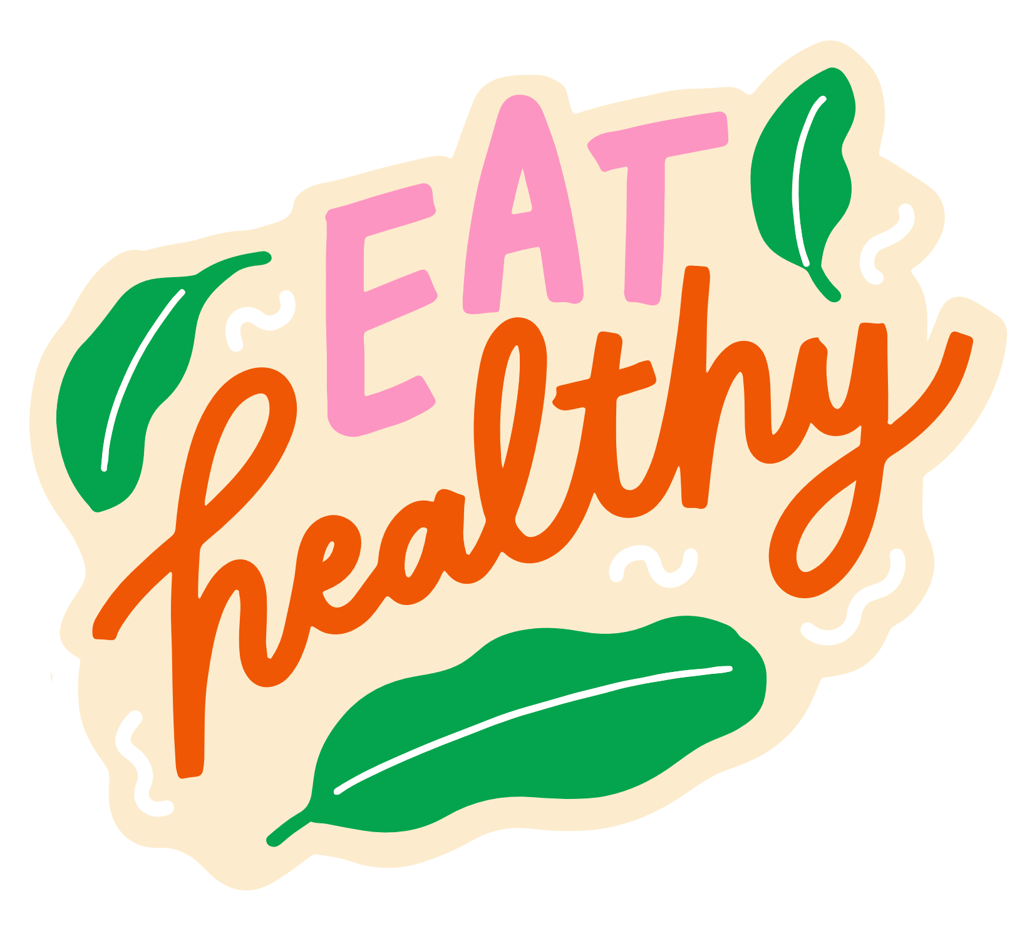

Healthy

GROCERY LIST

Grapes

FRUITS

Apples

Pears

Watermelon

Oranges

Bananas

Mango

Strawberries

Pickles

SNACKS/EXTRAS

Pickles okra

Peanut butter

Spices/Seasonings

Balsamic vinegar

Olive oil

Almonds

Olive oil mayo

Coconut oil

Organic free-range eggs

DAIRY & EGG

Kefir

Unsweetened almond milk

Aged cheddar

Greek yogurt

Low-fat cottage cheese

Organic cheese sticks

Sheep's milk ricotta

Quinoa

CARBS

Farro

Oats

Brown rice

Potatoes

Tofu

PROTEIN

Low fat beef jerky

Turkey breast

Chicken

Albacore tuna

Lacinato kale

VEGETABLES

Baby spinach

Cauliflower

Avocado

Organic lemons

Radishes

Tomatos

Onions

Bell peppers