United States

China

Other Asian countries

Europe

Assembly

in China

Intermediate warehouses

Warehouse facility

Direct sales force

Retail store

Online store

Warranty return, trade in program, recycle program

Wholesalers, retailers, network carriers

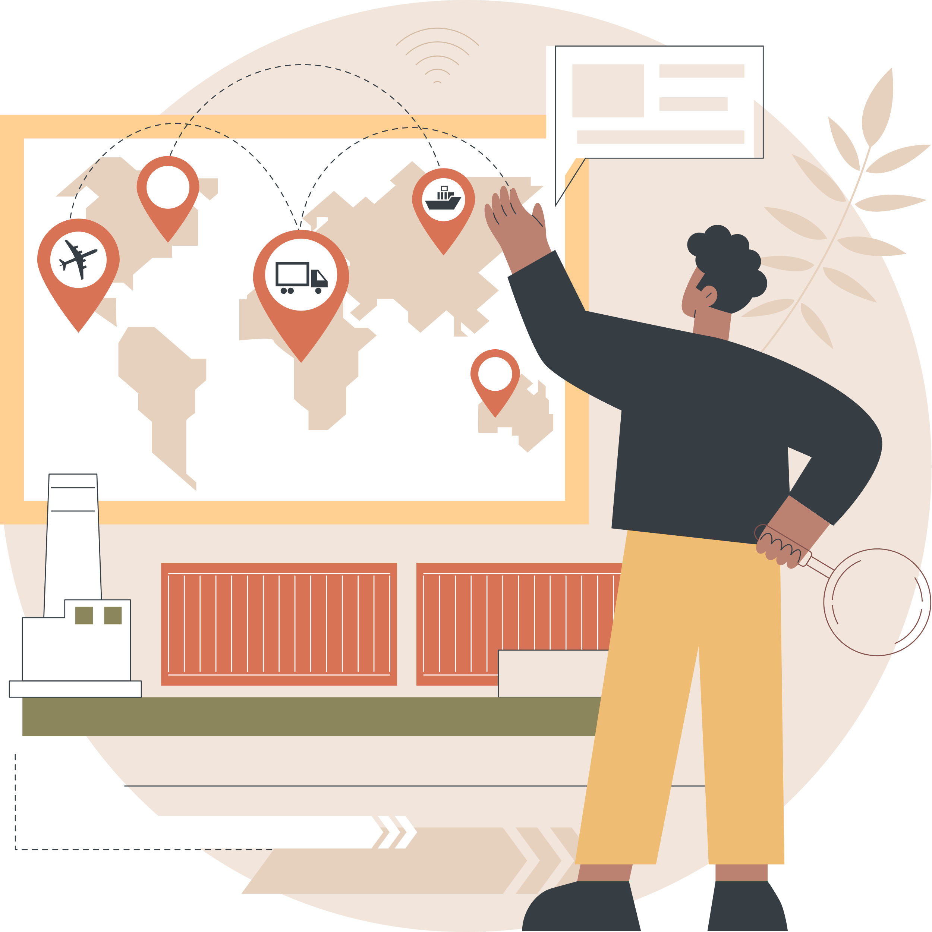

SUPPLY CHAIN PROCESS MAP