 |  | PHASES
 |  | PLANNING | DEVELOPMENT | REVIEW | PUBLISH
ROLES | TEACHER | Define curriculum  Start  Develop  course content  Review course  Pass?  Review update request  Public course  End  Yes  No
 | REVIEWER
 | TEACHING ASSISTANT
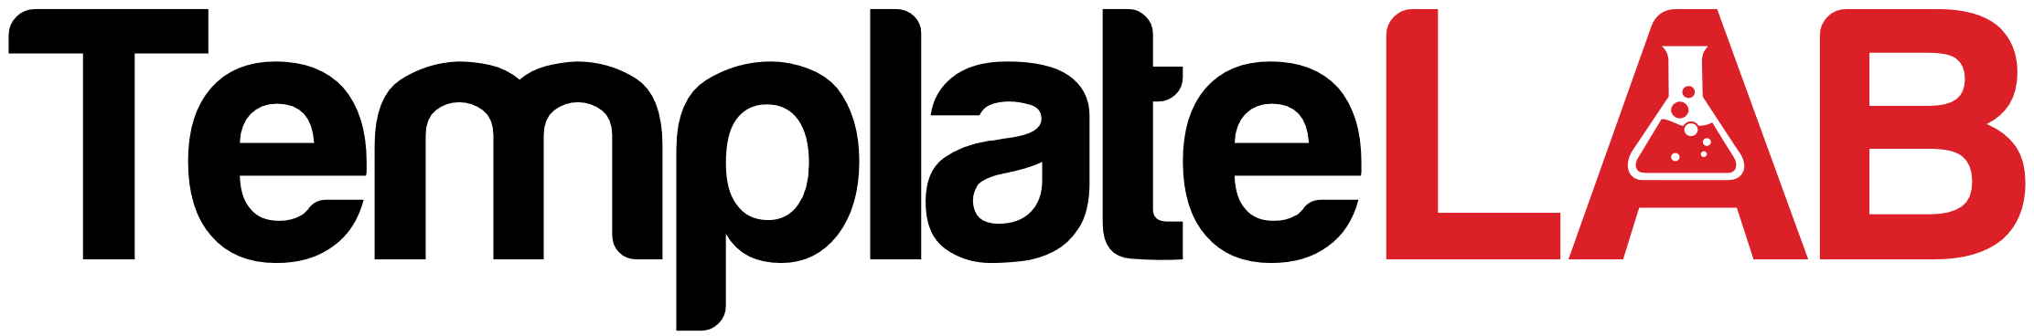
CROSS FUNCTIONAL PROCESS MAP

