Promissory Note Instructions
Your promissory note template starts on the next page. To get step-by-step instructions on how to fill out this promissory note, please follow the instructions below.
Step 1. Search for “FormSwift Promissory Note”
Search for “formswift promissory note” on https://google.com and click the link that reads https://formswift.com/promissory-note.
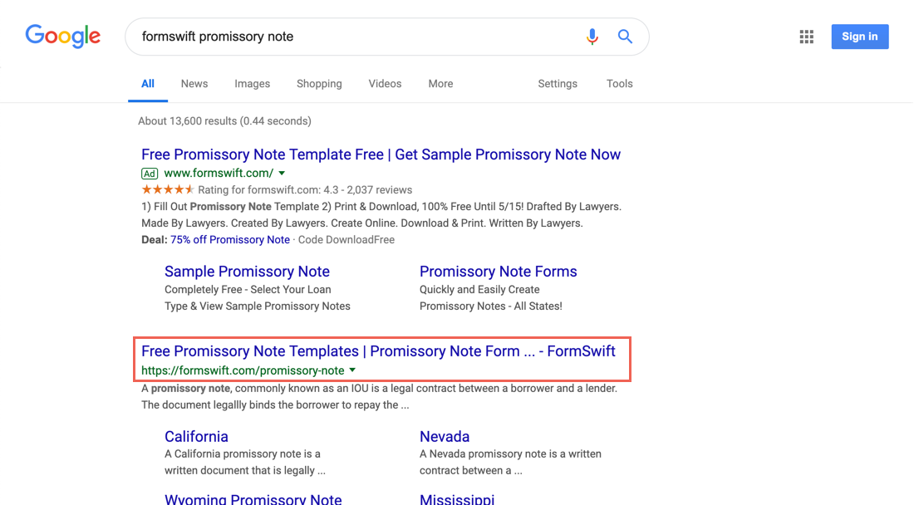
Step 2. Find the Writing a Promissory Note Section
Scroll down until you see the Writing a Promissory Note section on the page. It should look something like below.
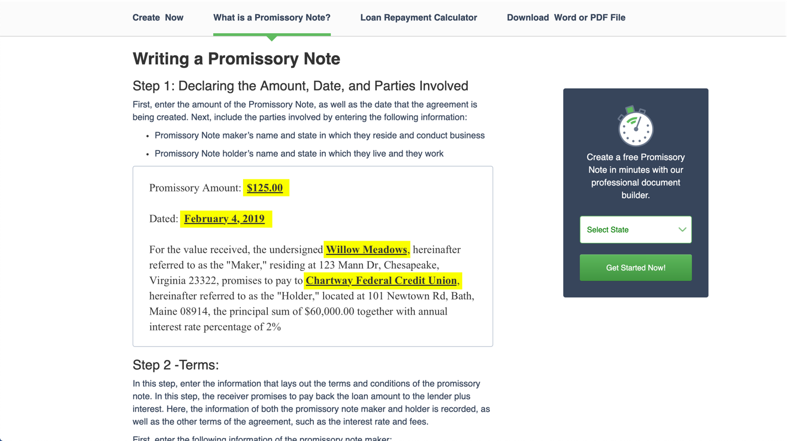
Step 3. Follow the Steps in the Guide
Review each step and decide what is the best way to fill out for your specific scenario. If you find these steps helpful, feel free to share the guide by providing the proper attribution with a link to formswift.com/promissory-note.

PROMISSORY NOTE

Promissory Amount: ________________________

Dated: ________________________

For the value received, the undersigned ________________________, hereinafter referred to as the "Maker," residing at ________________________, ________________________, ________________________ ________________________, promises to pay to ________________________, hereinafter referred to as the "Holder," located at ________________________, ________________________, ________________________ ________________________, the principal sum of ________________________ from the date hereof until the sum owed is paid in full, as hereinafter provided and upon the following terms and conditions.

MAKER'S PROMISE TO PAY
IN RETURN FOR VALUE RECEIVED, the Maker promises to pay to the Holder the Guaranteed Debt as described below under Guaranteed Debt Section, including principal amount of the note with interest or holding, handling or processing fee, if any, late charges, returned payment charges, and all other amounts that may become due under this Note. Maker acknowledges and agrees that it is the Maker's responsibility to repay amounts due under this Note and to uphold the obligations under this Note.

PAYMENT TERMS
- Terms. Payments shall be made on a ________________________ basis, in the amount of ________________________ beginning on the ________________________ day of ________________________ ________________________.
- Delivery. Payments shall be delivered to the Holder at the address shown above or any other such address as may later be agreed upon by both parties.
- Prepayments. If the Maker prepays the Note in part, the Maker agrees to continue to make the regularly scheduled payments until all amounts due under this Note are paid.

FAILURE TO PAY
- Late Charges. If the Holder has not received the full amount of any monthly payments after the , the Maker shall owe a late payment fee to the Holder of ________________________, due immediately in addition to the previously owed balance. If the owed balance and the late fee is not paid promptly and immediately, the Holder may, at his/her option, declare the Note in default.
- Default. Maker will be in default for any of the following reasons: (i) Maker does not pay the full amount of each monthly payment by the date stated in Repayment Terms above; (ii) if Maker defaults on any promise made in this Note or any other note, loan, or agreement with the Holder; (iii) if Maker has made any untrue statement or misrepresentation in the Maker's application or any other certificate or document given or made for this Note; (iv) death of the Maker; (v) if the Maker files a bankruptcy petition or anyone files an involuntary bankruptcy petition against the Maker; or (vi) if the Maker becomes insolvent and/or cannot pay the Maker's debts as they become due.
- Acceleration. At any time the Maker is in default, Holder may require the Maker to pay the full amount due under the Note. Even if, at a time when Maker is in default, the Holder does not require Maker to pay immediately in full as described, the Holder will still have the right to do so if Borrower is in default at a later time.
- Notice. If Maker is in default for ten (10) days, the Holder may send Maker a written notice stating that Maker is in default and if the overdue amount is not paid by a certain date, the Note Holder may require Maker to pay immediately the full amount of principal which has not been paid and all interested owed on the amount.
- Payment of Note Holder's Costs and Expenses. If the Note Holder has required Maker to pay immediately in full as described above, the Holder will have the right to be reimbursed for all of its costs and expenses to the extent not prohibited by applicable law, including but not limited to, outside collection agencies and reasonable attorney's fees.

GUARANTEED DEBT
________________________ agrees that the Guaranteed Debt shall consist of all amounts owed by Maker under this Promissory Note, including, but not limited to: (i) the Principal amount; (ii) Note Interest; (iii) Default Interest; (iv) Late Charges, (v) Insufficient Funds Charges; (vi) amounts owed as a consequence of a declared Event of Default and acceleration by Holder; and (vii) Holder's other costs and expenses of enforcing the Promissory Note including, but not limited to, attorneys' fees, and the costs of any arbitration proceeding to enforce the Note against Maker.

CONTINUING GUARANTY
This Guaranty is a continuing and irrevocable guaranty of the Guaranteed Debt and shall remain in full force and effect until the Guaranteed Debt and any other services or amounts payable under this Guaranty, is paid in full. This Guaranty shall continue to be effective, or be reinstated, as if such payment or services had not been made, if at any time any payment or services of any portion of the Guaranteed Debt is rescinded or must be restored or returned by Holder to Maker upon the insolvency or bankruptcy of the Maker or otherwise, this Guaranty shall: (i) bind Maker and Maker's executors, administrators, successors and assigns, provided that the Maker may not assign rights or obligations under this Guaranty without Holder's prior written consent; and (ii) inure to the benefit of Holder and its successors and assigns.

NOTICE
Any notice that must be given to Maker under this Note will be given by delivering it or by mailing it by certified mail addressed to Maker at the Maker's address above. If Maker provides a different address, than the address listed above, Holder must give notice to Maker at the most current address provided. Any notice that must be given to the Note Holder under this Note will be given by mailing by certified mail to the Note Holder at the Holder's address above. If Note Holder provides a different address, than the address listed above, Maker must give notice to Holder at the most current address provided.

MODIFICATION
No modification or waiver of any of the terms of the Agreement shall be allowed unless by written agreement signed by both parties. No waiver of any breach or default hereunder shall be deemed a waiver of any subsequent breach or default of the same or similar nature.

GOVERNING LAW
This Note shall be construed in accordance with and governed by the laws of the State of ________________________.

ASSIGNMENT

SUCCESSORS
The terms and conditions of this Promissory Note shall inure to the benefit of and shall be binding and severally upon the successors, assigns, heirs, survivors and personal representatives of the Maker and Holder and shall inure to the benefit of any Holder, legal representatives, successors and assigns.

WAIVER
The aforementioned parties acknowledge that no breach of any provision of the Promissory Note shall be deemed waived unless evidenced in writing. A waiver of any one breach shall not be deemed as a waiver of any other breach of the same or any other provision of the Promissory Note.

SEVERABILITY
In the event that any provision, clause, sentence, section or other part of this Promissory Note is held to be invalid, illegal, inapplicable, unconstitutional, contrary to public policy, void or unenforceable in law to any person or circumstance, Maker and Holder intend that the balance of this Promissory Note shall nevertheless remain in full force and effect so long as the purpose of this Promissory Note is not affected in any manner adverse to either party.

AMENDMENT OF PROMISSORY NOTE
This Promissory Note may be amended or modified only by way of written agreement duly executed by the Holder and Maker of this Promissory Note.

SIGNATURES:
_________________________________________________  (Signature of Holder)  ________________________ | __________________________  (Date)
_________________________________________________  (Signature of Maker) | __________________________  (Date)

NOTARY ACKNOWLEDGMENT

On ___________________ the aforementioned Maker and Holder did personally appear before me, and being personally known to me (or proven to me on the basis of satisfactory evidence) to be the persons whose names are subscribed to the within instrument and acknowledged to me that they executed the same in their authorized capacity, and that by their signatures on the instrument above, or the entity upon behalf of which the person(s) acted, executed the instrument.

WITNESS my hand and official seal.

_______________________________________________________
(NOTARY SIGNATURE)
My Commission Expires: ___________________________________

