Company Name Address

Telephone

Last Revision Date

Program Administration
Define the scope, objectives, and assumptions of the business continuity plan.

Business Continuity Organization
Define the roles and responsibilities for team members.
Identify the lines of authority, succession of management, and delegation of authority. Address interaction with external organizations including contractors and vendors.

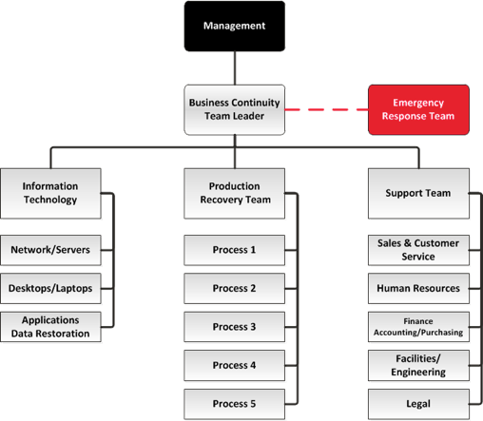

Figure 1. Example Business Continuity Team Organization Chart

Team  (IT, Production, Support) | Member Name | Email | Work Telephone | Home / Cell Telephone

Business Impact Analysis
•Insert results of Business Impact Analysis
•Identify Recovery Time Objectives for business processes and information technology
•Identify Recovery Point Objective for data restoration

Business Continuity Strategies & Requirements
- Insert detailed procedures, resource requirements, and logistics for execution of all recovery strategies
•Insert detailed procedures, resource requirements, and logistics for relocation to alternate worksites
•Insert detailed procedures, resource requirements, and data restoration plan for the recovery of information technology (networks and required connectivity, servers, desktop/laptops, wireless devices, applications, and data)

Manual Workarounds
- Document all forms and resource requirements for all manual workarounds

Incident Management

Define procedures:
- Incident detection and reporting
- Alerting and notifications
- Business continuity plan activation
- Emergency operations center activation
- Damage assessment (coordination with emergency response plan) and situation analysis
- Development and approval of an incident action plan

Training, Testing & Exercising
- Training curriculum for business continuity team members
- Testing schedule, procedures, and forms for business recovery strategies and information technology recovery strategies
- Orientation, tabletop, and full-scale exercises

Program Maintenance and Improvement
- Schedule, triggers, and assignments for the periodic review of the business continuity and IT disaster recovery plan
- Details of corrective action program to address deficiencies

Appendix

References to Related Policies & Procedures
- Emergency Response Plan
- Information Technology Disaster Recovery Plan (if not included in the business continuity plan)
- Crisis Communications Plan
- Employee Assistance Plan

Vendors & Contractors

Company | Contact Name | Emergency Telephone | Business Telephone

Revision History

Revision No. | Date | Description of Changes | Authorization

Plan Distribution & Access

The Plan will be distributed to members of the business continuity team and management. A master copy of the document should be maintained by the business continuity team leader.

Provide print copies of this plan within the room designated as the emergency operations center (EOC). Multiple copies should be stored within the EOC to ensure that team members can quickly review roles, responsibilities, tasks, and reference information when the team is activated.

An electronic copy of this plan should be stored on a secure and accessible website that would allow team member access if company servers are down.

Electronic copies should also be stored on a secure USB flash drive for printing on demand.

