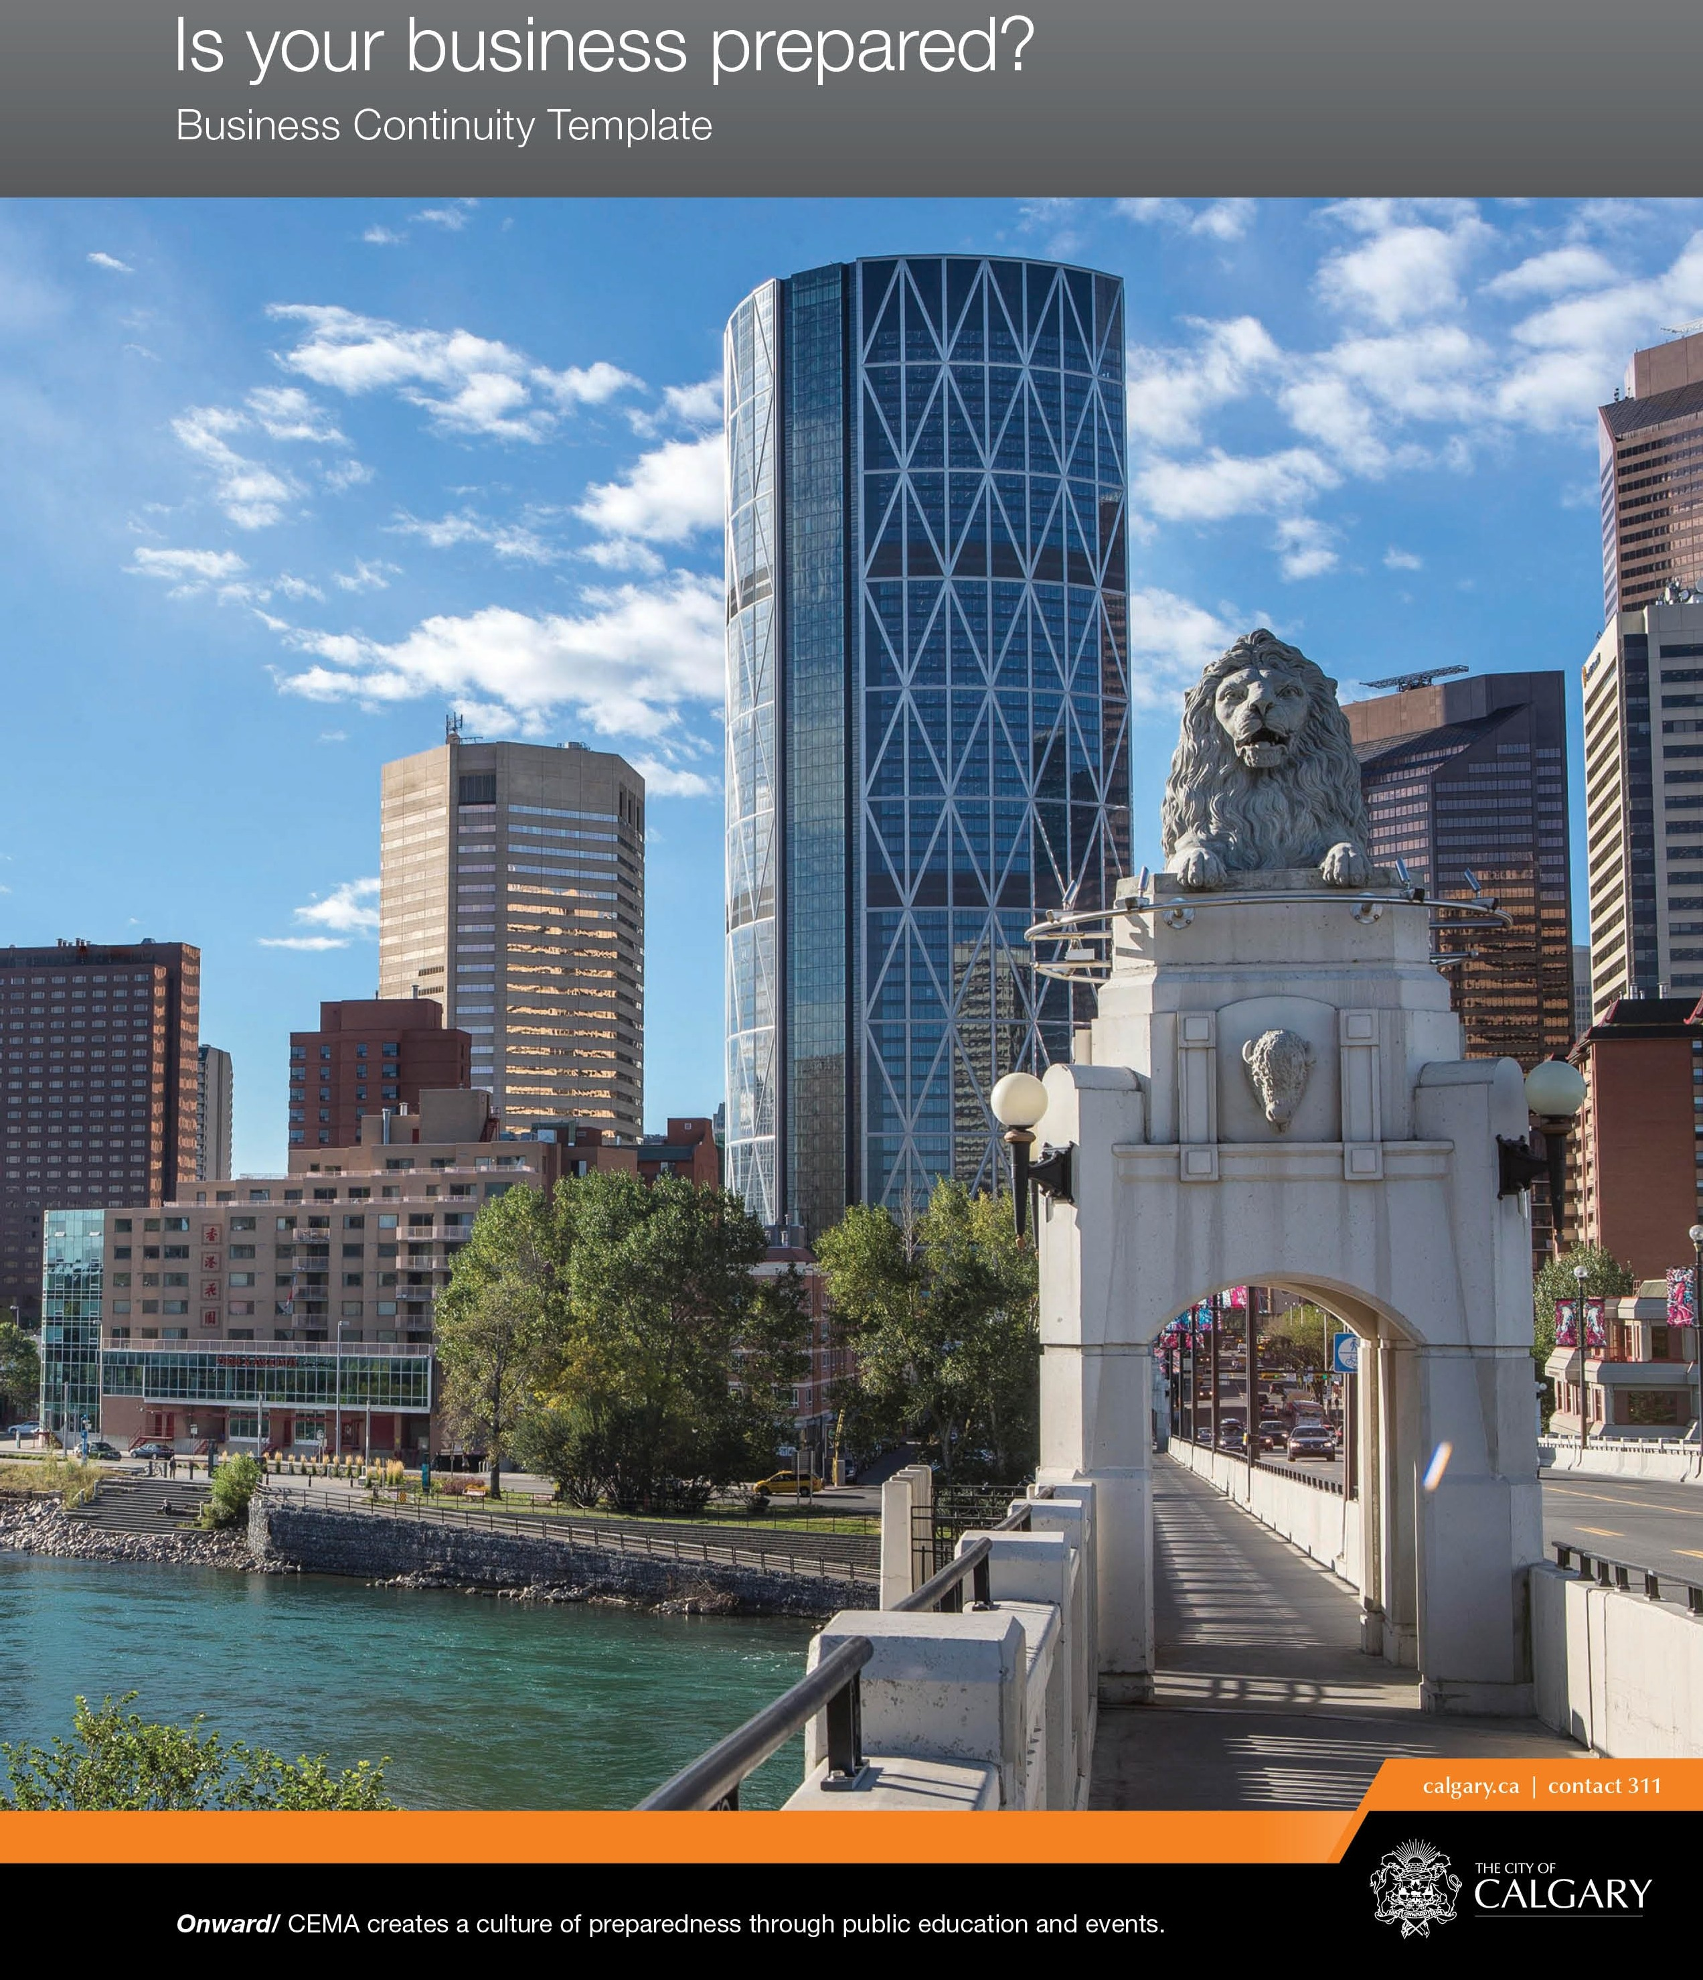

FOREWORD

The 2013 southern Alberta floods had a significant impact on the business community in Calgary. Many businesses were forced to close temporarily as they cleaned up, while a small number were impacted so severely that they were unable to resume their business operations altogether.
The Calgary Emergency Management Agency (CEMA) recognizes the importance of the business sector as an essential member of the Calgary community. The resumption of business activities is a critical component of overall community recovery following a disaster.
The 2013 floods were a call to action for both the business sector and The City of Calgary. The flood highlighted the need for businesses to be further prepared in advance of a major event causing disruption to business activities. A disruption can be large, such as the flood event, or it can be as simple as a system failure interrupting important business data. This business continuity guide was developed to assist small- and medium-sized businesses plan for the continuity and resumption of business operations following a disruption.
This guide is a coordinated and cooperative effort between CEMA and the Calgary Chamber of Commerce. CEMA believes that this exciting partnership with the business community is a significant step in ensuring that Calgary businesses are well-served and well-prepared for any future challenges.

2

DIRECTIONS

- Use the Business Continuity Reference Guide to assist you in completing the Business Continuity Template (available for download at calgary.ca/cema).

- Fill out the Business Continuity Plan Template.

- Create duplicates and/or expand sections as needed (e.g. Action Plan Template, Exercise Log).

- Save and print your Business Continuity Plan

LIST OF ABBREVIATIONS

3

AEMA Alberta Emergency Management Agency
BCP Business Continuity Plan
BCM Business Continuity Manager
CEMA Calgary Emergency Management Agency
DRP Disaster Recovery Program
RTO Recovery Time Objective

Register your business with Calgary Chamber’s Emergency Business Contact Database to receive relevant alerts during an emergency.
CalgaryChamber.com/Emergency

INTRODUCTION

There are five steps to developing an effective Business Continuity Plan:

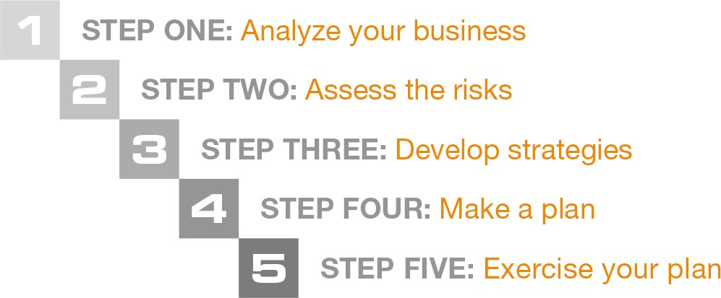

To develop an effective Business Continuity Plan, tailor it according to the nature of your business and its operations. The user is encouraged to customize this template to meet their business’s needs.

4

CONTENTS
5
FOREWORD 2
DIRECTIONS 3
LIST OF ABBREVIATIONS 3
INTRODUCTION 4
BUSINESS CONTINUITY PLAN INFORMATION 7
REVISION LIST 8
DISTRIBUTION LIST 9
VITAL INFORMATION 10
Associated Policies, Documents, and Procedures 10
Staff Contact Numbers 11
Emergency Contact List 12

Supplier Contact List 13
Customer Contact List 14
STEP ONE: ANALYZE YOUR BUSINESS 15
Employee Roles and Responsibilities 17
Key Business Functions 18
Recovery Time Objective (RTO) 19
Impact 20
Impact Cont. 21
STEP TWO: ASSESS THE RISKS 23
Risk Matrix. 24
STEP THREE: DEVELOP STRATEGIES 27
6
STEP FOUR: MAKE A PLAN 30
Evacuation Procedures and Routes 30
Action Plan Template 31
STEP FIVE: EXERCISE YOUR PLAN 37
Exercise Process. 37
Types of Exercises 37
Workshops 37
Tabletop 37
Full-Scale 38
Exercise Log 38
STAY INFORMED 42

BUSINESS CONTINUITY PLAN INFORMATION
COMPANY NAME
BUSINESS CONTINUITY MANAGER
CONTACT INFORMATION
ALTERNATE MANAGER
CONTACT INFORMATION
BUSINESS CONTINUITY PLAN
LOCATION

7

REVISION LIST

REVISION
NUMBER DETAILS REVISED BY REVISION DATE

8

DISTRIBUTION LIST

NAME DETAILS DATE

9

VITAL INFORMATION

BUSINESS LICENCE NUMBER
INSURANCE POLICY NUMBER
CRITICAL PAPER RECORDS LOCATION
BACK-UP COMPUTER RECORDS
LOCATION

ASSOCIATED POLICIES, DOCUMENTS, AND PROCEDURES

FILE LOCATION DATE UPDATED

10

STAFF CONTACT NUMBERS

NAME TITLE PHONE #1 PHONE #2

11

EMERGENCY CONTACT LIST

NAME TITLE PHONE #1 PHONE #2

12

SUPPLIER CONTACT LIST

NAME COMPANY PHONE #1 PHONE #2

13

CUSTOMER CONTACT LIST

NAME COMPANY PHONE #1 PHONE #2

14

STEP ONE: ANALYZE YOUR BUSINESS

What is the purpose of your business?

What products and services do you provide?

15

How do you provide your products and services? (e.g. web store, shop, delivery)

Do your service providers have business continuity plans in place?

What are your resource requirements? (e.g. suppliers, equipment, records)

Who is involved in the daily operations? (e.g. employees, suppliers)

Who are your customers?

16
Business Continuity Template

EMPLOYEE ROLES AND RESPONSIBILITIES

POSITION ROLES AND RESPONSIBLITIES

17

KEY BUSINESS FUNCTIONS

BUSINESS FUNCTION STAFF REQUIREMENTS RESOURCE REQUIREMENTS

18

RECOVERY TIME OBJECTIVE (RTO)

BUSINESS
FUNCTION <24 HRS 48 HRS 72 HRS 1 WEEK 2 WEEKS 1 MONTH

19

IMPACT

BUSINESS FUNCTION POTENTIAL IMPACTS

20

IMPACT CONT.

BUSINESS FUNCTION POTENTIAL IMPACTS

21

NOTES:

22

STEP TWO: ASSESS THE RISKS

Calgary is exposed to different types of risks such as natural hazards, human- caused hazards, and technological hazards. Each potential risk carries unique needs which may require special planning.

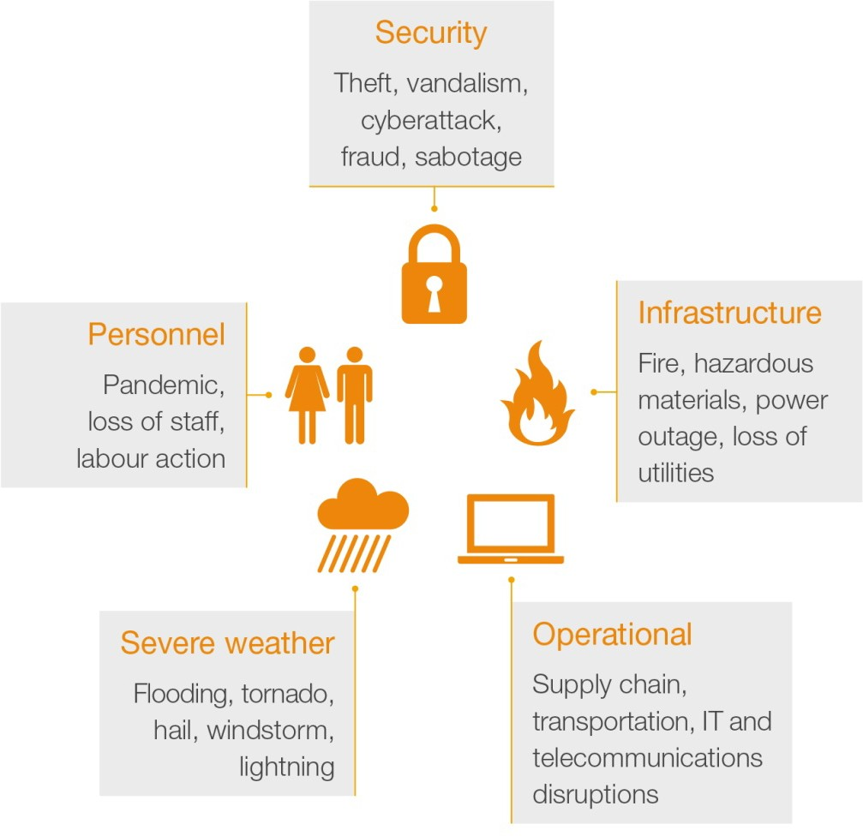

23

The following demonstrates the risks and hazards that your business may be vulnerable to. Assess each risk and imagine how they could potentially affect your ability to continue operating.

RISK MATRIX

Various risks and hazards have different severities and likelihood of occurring. Consider the different hazards in the previous page and use the risk assessment matrix below to assess the potential hazards to your business.

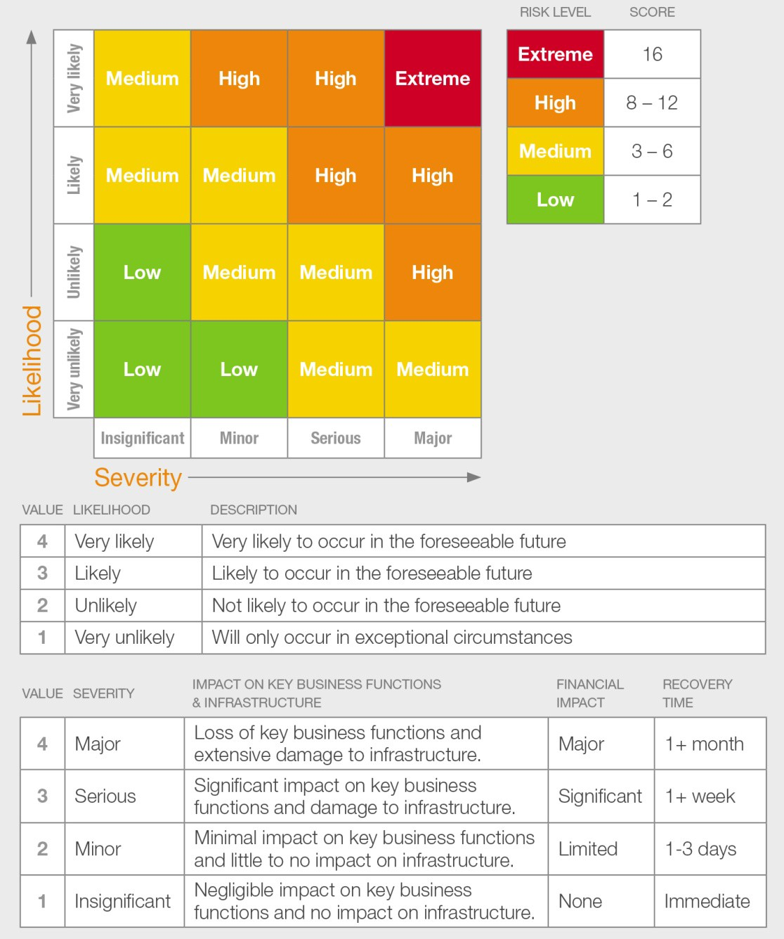

24

To calculate the risk level, multiply the hazard’s likelihood value by the severity value (likelihood x severity = risk level). Prioritize your planning based on the risk value.

HAZARD RISK LEVEL PLANNING MEASURES
Choose Risk Level
Choose Risk Level
Choose Risk Level
Choose Risk Level
Choose Risk Level
Choose Risk Level
Choose Risk Level
Choose Risk Level
Choose Risk Level
Choose Risk Level

25

NOTES:

26

STEP THREE: DEVELOP STRATEGIES

What strategies can you implement BEFORE a disruption occurs?

27

What strategies can you implement DURING a disruption?

28

What strategies can you implement AFTER a disruption has occurred?

29

STEP FOUR: MAKE A PLAN

EVACUATION PROCEDURES AND ROUTES

Evacuation Procedures:

- Cease all other activities (phone calls, meetings, etc.)
- Remain calm and follow directions from floor wardens or emergency services personnel
- Do not return to your workspace for personal possessions; evacuate from where you are
- Walk, do not run, to nearest safe exit. Use stairwell, NOT elevators
- Direct all visitors to the nearest safe stairwell
- Know the alternate evacuation routes
- Check doors for heat, using the back of your hand before opening. If a door is hot, use an alternate route
- Close all doors behind you and proceed to the muster point
- Remain at the muster point and do not re-enter the building until instructed by emergency personnel

30
Evacuation Routes:

Draw or print out a map showing the muster points and exit routes in the space provided below.
Muster Point: Secondary:

Exit Route: Secondary:

ACTION PLAN TEMPLATE
RISK
RISK LEVEL
RTO
BUSINESS FUNCTIONS AFFECTED
POTENTIAL IMPACT
ACTION | BEFORE
 | DURING
 | AFTER
RESOURCE REQUIREMENTS
STAFF REQURIEMENTS

31

RISK
RISK LEVEL
RTO
BUSINESS FUNCTIONS AFFECTED
POTENTIAL IMPACT
ACTION | BEFORE
 | DURING
 | AFTER
RESOURCE REQUIREMENTS
STAFF REQURIEMENTS

32

RISK
RISK LEVEL
RTO
BUSINESS FUNCTIONS AFFECTED
POTENTIAL IMPACT
ACTION | BEFORE
 | DURING
 | AFTER
RESOURCE REQUIREMENTS
STAFF REQURIEMENTS

33

RISK
RISK LEVEL
RTO
BUSINESS FUNCTIONS AFFECTED
POTENTIAL IMPACT
ACTION | BEFORE
 | DURING
 | AFTER
RESOURCE REQUIREMENTS
STAFF REQURIEMENTS

34

RISK
RISK LEVEL
RTO
BUSINESS FUNCTIONS AFFECTED
POTENTIAL IMPACT
ACTION | BEFORE
 | DURING
 | AFTER
RESOURCE REQUIREMENTS
STAFF REQURIEMENTS

35

RISK
RISK LEVEL
RTO
BUSINESS FUNCTIONS AFFECTED
POTENTIAL IMPACT
ACTION | BEFORE
 | DURING
 | AFTER
RESOURCE REQUIREMENTS
STAFF REQURIEMENTS

36

STEP FIVE: EXERCISE YOUR PLAN

EXERCISE PROCESS

Develop Exercise
- exercise design
- scenario
- drills, tabletop exercise, orientation, full scale exercise

Evaluate Exercise
- ask for feedback from participants
- evaluate staff preparedness
- evaluate systems and equipment performance

Conduct Exercise
  - test the plan
  - test staff, equipment, and procedures
  - train staff, clarify roles and responsibilities

Revise BCP
- update the plan to ammend noted weaknesses and gaps

37

TYPES OF EXERCISES

Workshops
Workshops are designed to familiarize the employees with their roles and responsibilities as defined in the business continuity plan. Workshops are normally conducted in a classroom setting.

Tabletop
Tabletop exercises are designed to test a hypothetical business disruption. The focus is on training, familiarization with roles, responsibilities, and procedures. Tabletop exercises are guided by a facilitator that walks the employees through the process. It is conducted in a stress-free and informal environment where participants are encouraged to ask questions.

Full-Scale
Full-scale exercises attempt to simulate a real business disruption. This is as close as it gets to a real event. This exercise takes place on location where the hypothetical disruption has occurred. Actual equipment, personnel, and business partners are often included in a full- scale exercise.

EXERCISE LOG
EXERCISE NAME
DATE
DURATION
SCENARIO
BUSINESS FUNCTIONS TO BE
EXERCISED
PARTICIPANTS
COMMENTS AND
FINDINGS
RECOMMENDATIONS

38

EXERCISE NAME
DATE
DURATION
SCENARIO
BUSINESS FUNCTIONS TO BE
EXERCISED
PARTICIPANTS
COMMENTS AND
FINDINGS
RECOMMENDATIONS

39

NOTES:

40

NOTES:

41

STAY INFORMED

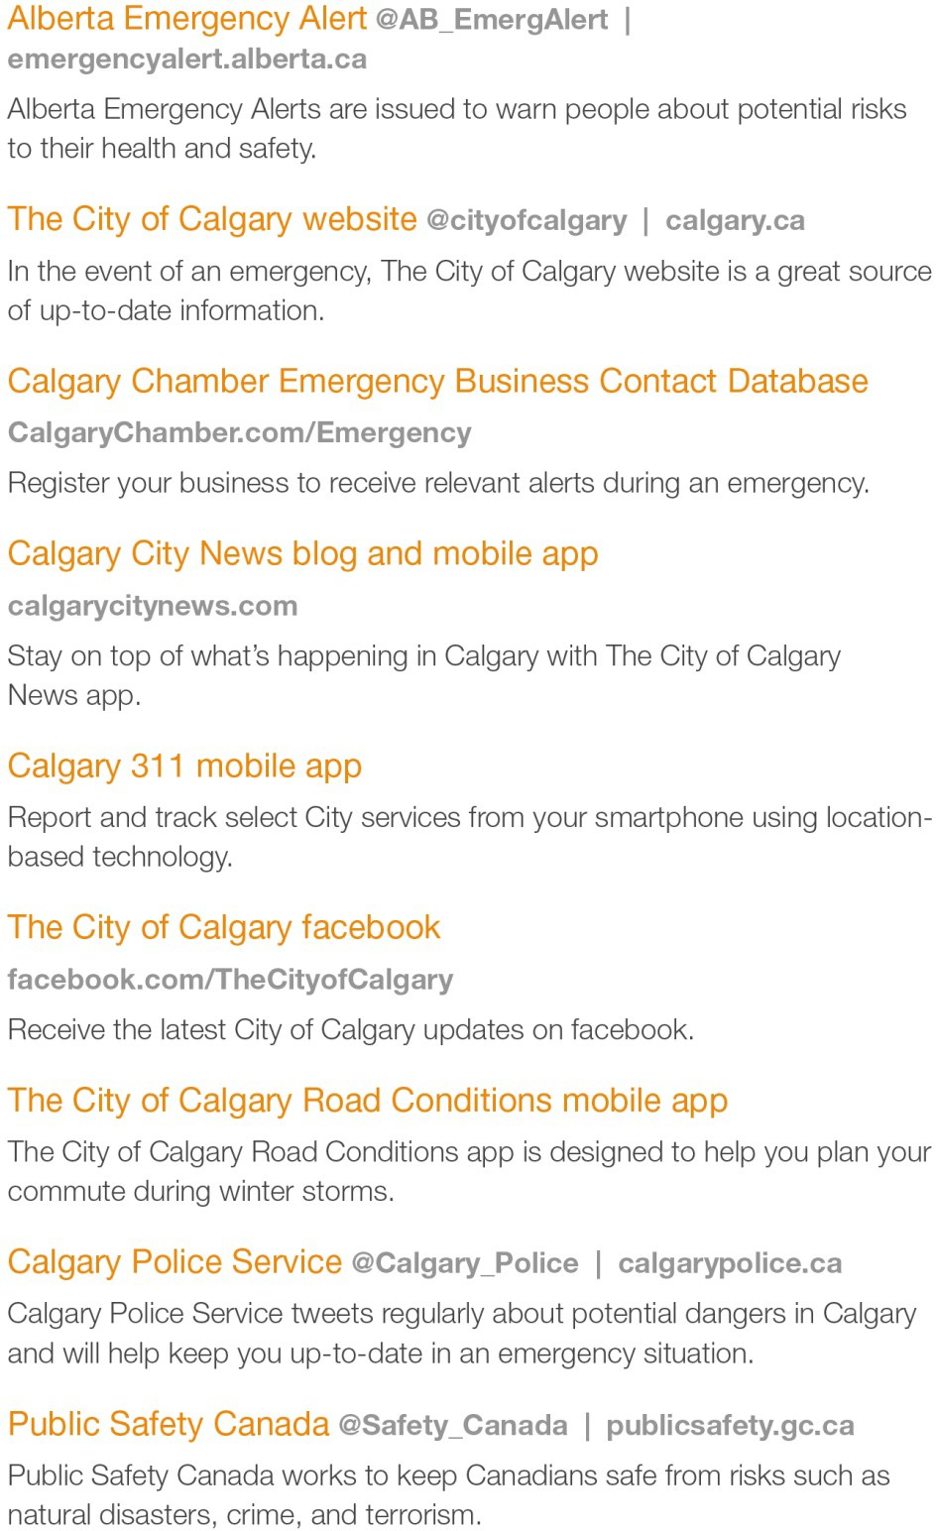

42

