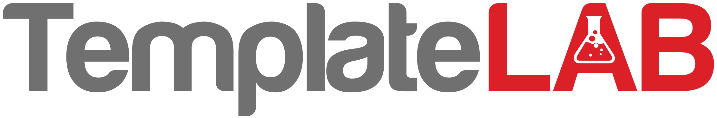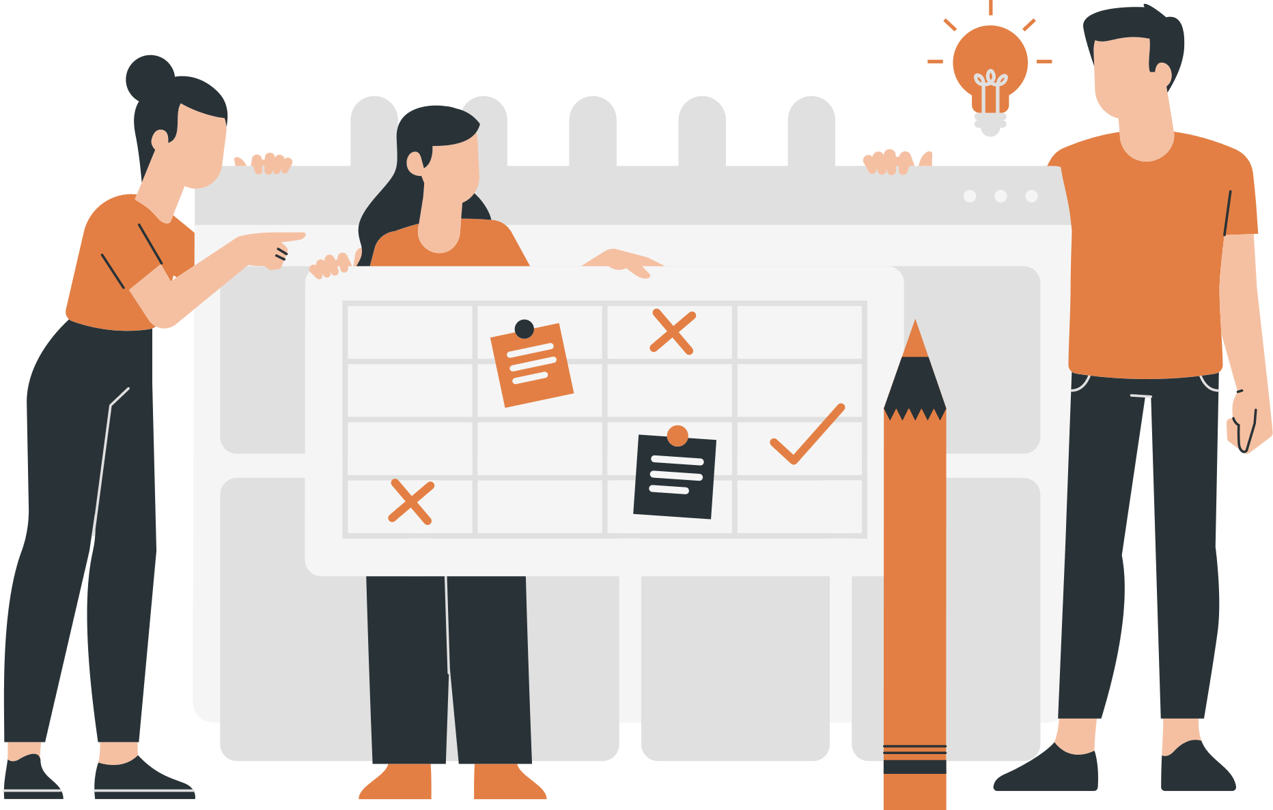

SMALL

BUSINESS

Solicitors

Other companies

Charities

Legal system

General counsel

Licensing

Funding

Customers

Decision makers

Other suppliers

Manufacturing

Creative services

Out accountant auditor,

Comptroller,

Taxes,

Payroll

ORGANIZATIONAL ECOMAP