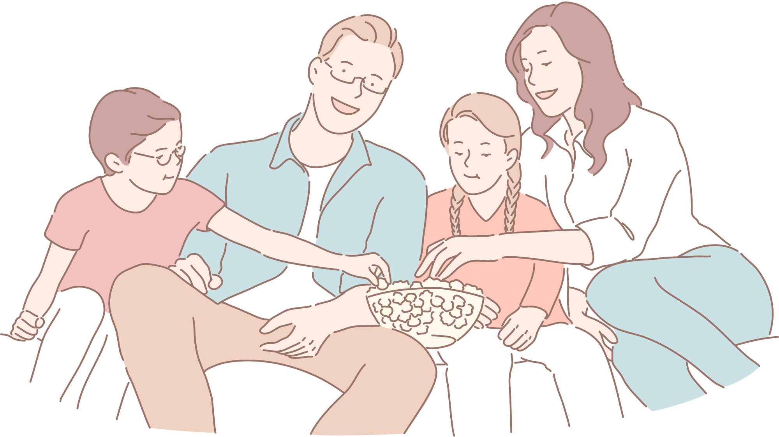

Hobbies

School

Friends

Hobbies

School

Friends

Child 1

Child 2

Family

Work

Hobbies

Material family

Father

Mother

Work

Family

Material family

FAMILY ECOMAP