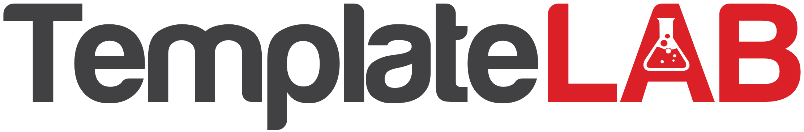

Work supervisor

Friends

School

Training programs

Clubs, Hobbies

Family

Peers

Sports

Siblings

Neighbour

Father

Mother

**BELLA**

a solid or thick line represents an important, strong or positive connection

a broken line represents a tenuous or weak connection

arrows along the line point towards the directions or flow of resources, energy or interest.

line with crosses throgh them indicate a stressful relationship

Identify the quality of the relationship between the formal and informal support through the use of lines:

**ECOMAP SOCIAL WORK**