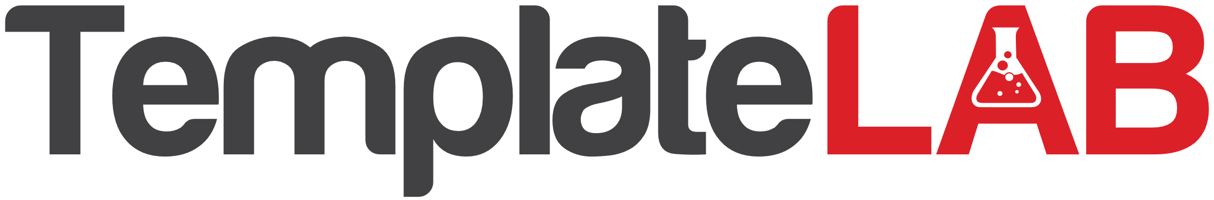

ECOMAP SOCIAL WORK

John

Smith

line with crosses throgh them indicate a stressful relationship

arrows along the line point towards the directions or flow of resources, energy or interest.

a broken line represents a tenuous or weak connection

a solid or thick line represents an important, strong or positive connection

Hiking group

Sally

Book club

David

Annie

Surfing club

Peers

Church