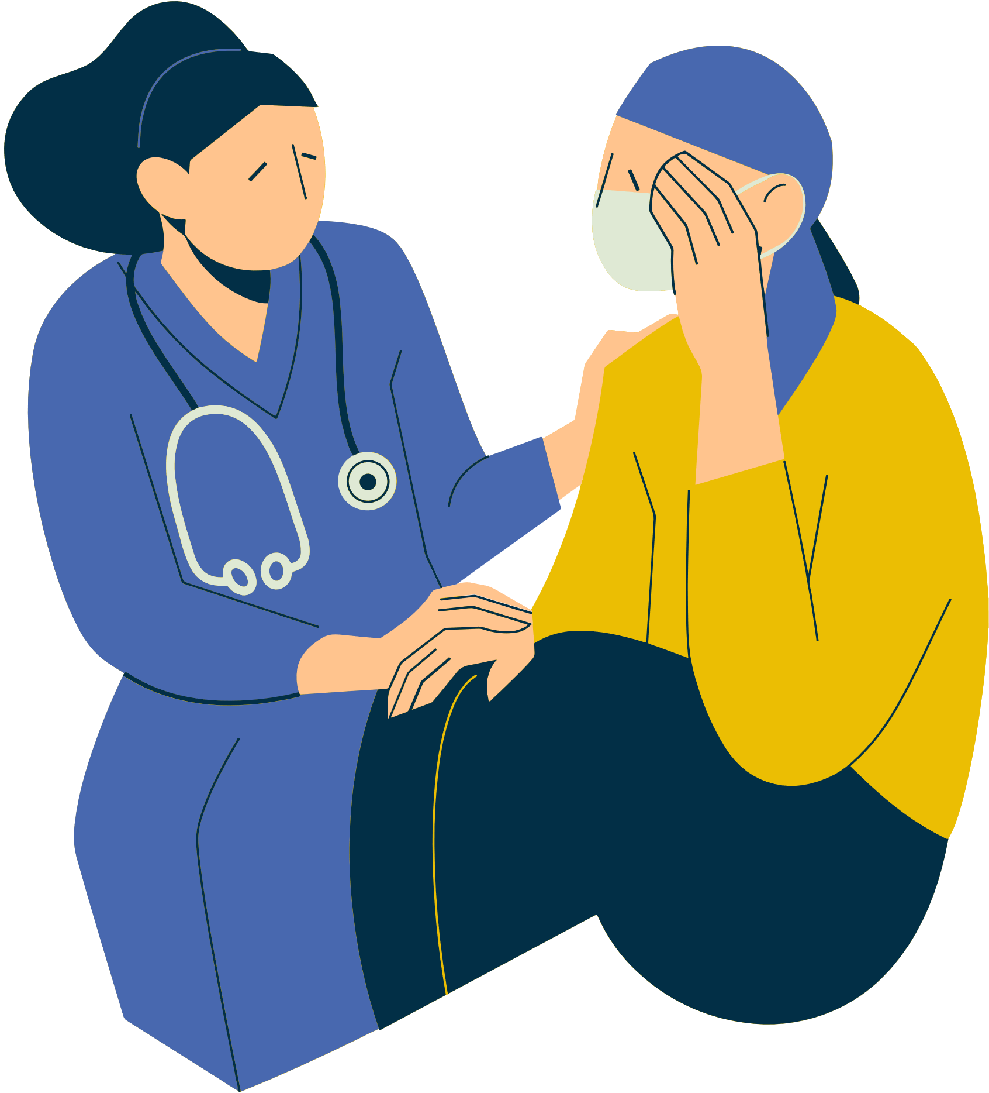

healthy relationship

weak relationship

stressful relationship

**Michelle**

Mom

Dad

Sofia (Sister)

Sarah (Sister)

Hannah

(Friend)

Bella

(Friend)

Nicole

(Coach)

Laura

(Therapist)

David

(Partner)

Gym club

**ECOMAP NURSING**

Patient name**: Michelle Evans**

Filled out by: **Annie Gahegan**

Date: **August 16, 2029**

Contact: **+123 456 789**

***Instructions: Keep tracking of the patient's health and identify the source of their stress. List the names of the people with whom they have regular contact and explain how each of them is related to the patient using they key assigned.***