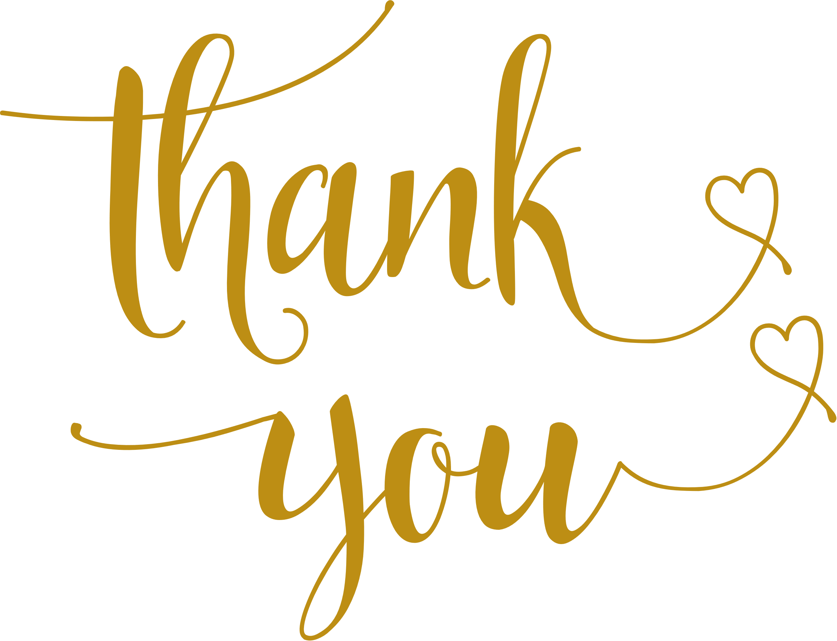

for sharing our joyous accession.

your lovely gift and thoughtfulness  
 are very much appreciated.

MARRY

& DAVID

AUGUST 08, 2028