 |  |  |  |  |  |  | 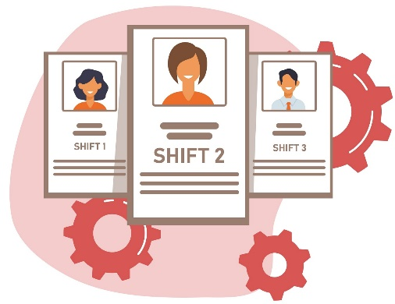
 | EMPLOYEE SHIFT SCHEDULE
 | Company Name: | Best Bakery International
 | Department: | Breads & Cookies
 | EMPLOYEE NAME | 8AM | 9AM | 10AM | 11AM | 12PM | 1PM | 2PM | 3PM
 | SHIFT 1 | MONDAY 10/10/2022
 | Vivian Moore | Bagel | Bread roll | Bun | Flatbread | Cookie | Cake | Cracker | Cheese cracker
 | John Doe | Muffin | Brownie | Cracker | Bagel | Bread roll | Flatbread | Bun | Cake
 | Dorian Gray | Cake | Cracker | Cheese cracker | Muffin | Bun | Bread roll | Cookie | Brownie
 | EMPLOYEE NAME | 4PM | 5PM | 6PM | 7PM | 8PM | 9PM | 10PM | 11PM
 | SHIFT 2 | MONDAY 10/10/2022
 | Billy Thompson | Cake | Cracker | Cheese cracker | Muffin | Bun | Bread roll | Cookie | Brownie
 | Retta Gay | Muffin | Brownie | Cracker | Bagel | Bread roll | Flatbread | Bun | Cake
 | William Smith | Bagel | Bread roll | Bun | Flatbread | Cookie | Cake | Cracker | Cheese cracker
 | EMPLOYEE NAME | 12AM | 1AM | 2AM | 3AM | 4AM | 5AM | 6AM | 7AM
 | SHIFT 3 | TUESDAY 11/10/2022
 |  |  |  |  |  |  |  | © TemplateLab.com

