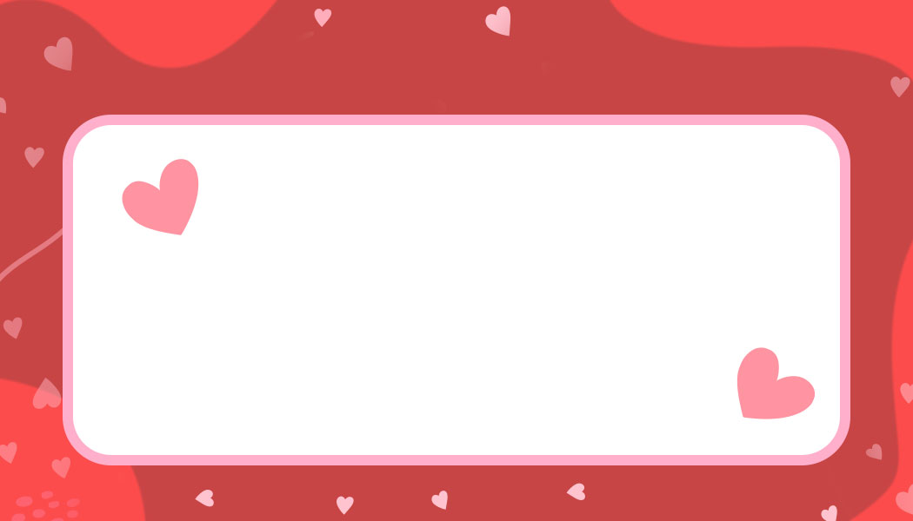



Happy Valentines Day!

Happy Valentines Day!

Happy Valentines Day!

Anne Marie

Scott

Mary

John

Happy Valentines Day!

Happy Valentines Day!

Happy Valentines Day!

Mary

John

Happy Valentines Day!

Scott

Anne Marie

Happy Valentines Day!

