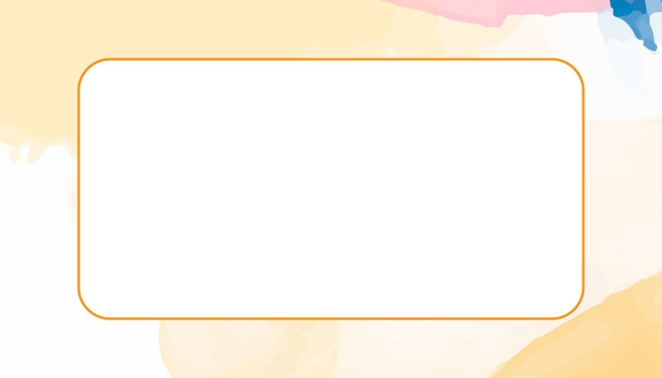



Blake Scott

HI, MY NAME IS

Anne Marie

HI, MY NAME IS

HI, MY NAME IS

Anne Marie

HI, MY NAME IS

Blake Scott

HI, MY NAME IS

Anne Marie

HI, MY NAME IS

Blake Scott

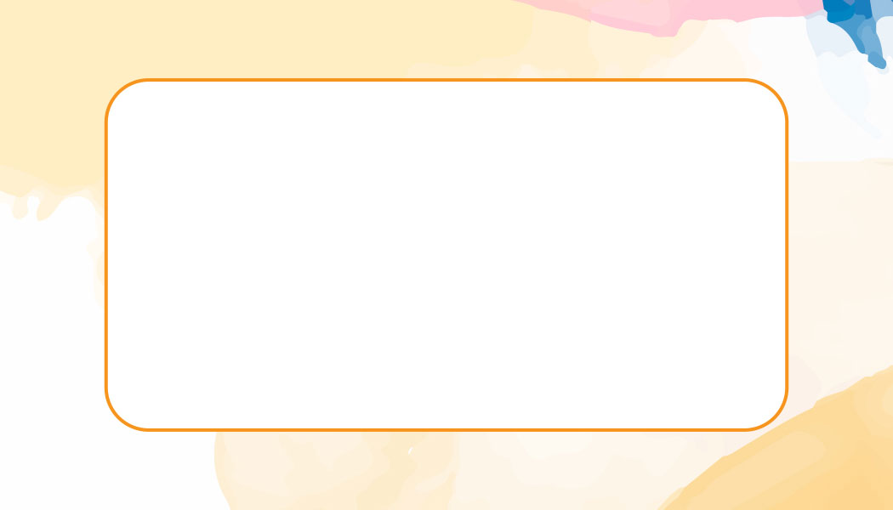

HI, MY NAME IS

Anne Marie

Blake Scott

HI, MY NAME IS