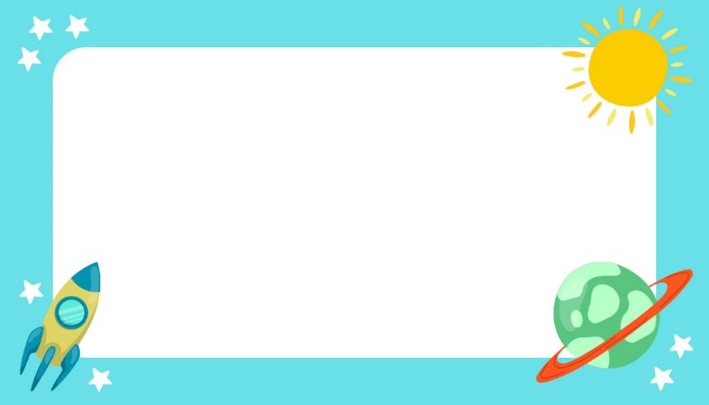

Anne Smith

HI, MY NAME IS

Blake Scott

HI, MY NAME IS

HI, MY NAME IS

John Doe

HI, MY NAME IS

Blake Scott

HI, MY NAME IS

Blake Scott

HI, MY NAME IS

Anne Smith

HI, MY NAME IS

John Doe

HI, MY NAME IS

Blake Scott

