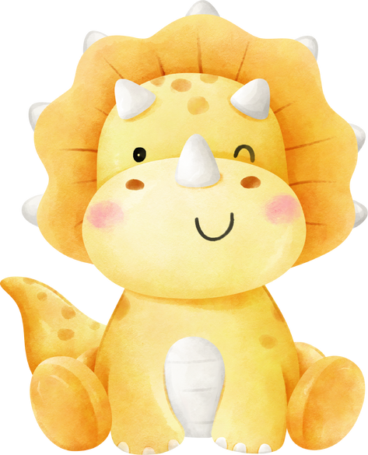

Hello!

My name is,

OLIVIA

