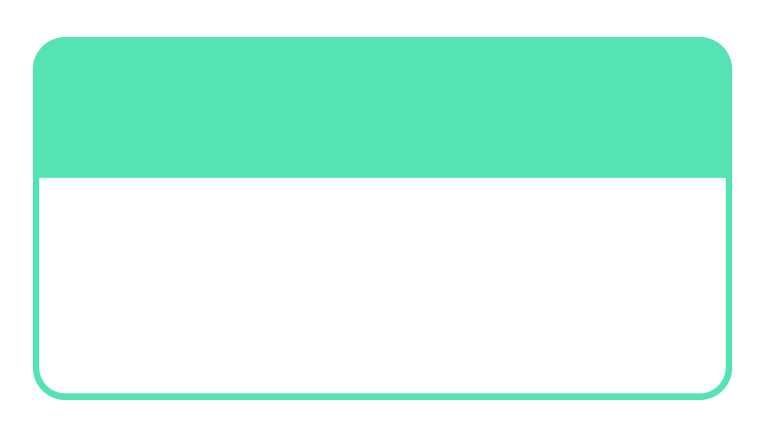



Harley

Hello, my name is

Smith

Hello, my name is

Michael

Hello, my name is

Andrea

Hello, my name is

Harley

Hello, my name is

Hello, my name is

Smith

Hello, my name is

Michael

Andrea

Hello, my name is

