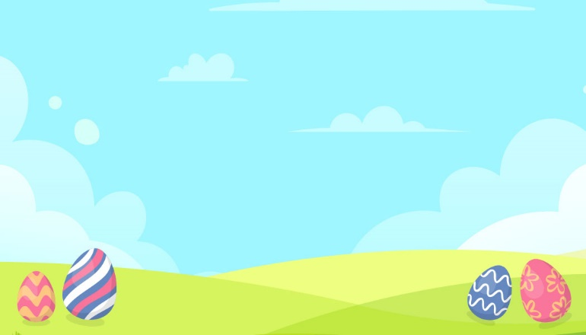



Mary

Harley

Mary

Harley

Simon

Hi, My name is

Happy Easter Day!

Happy Easter Day!

Hi, My name is

John

Hi, My name is

Happy Easter Day!

Hi, My name is

Happy Easter Day!

Simon

Hi, My name is

Happy Easter Day!

Happy Easter Day!

Hi, My name is

John

Hi, My name is

Happy Easter Day!

Happy Easter Day!

Hi, My name is

