

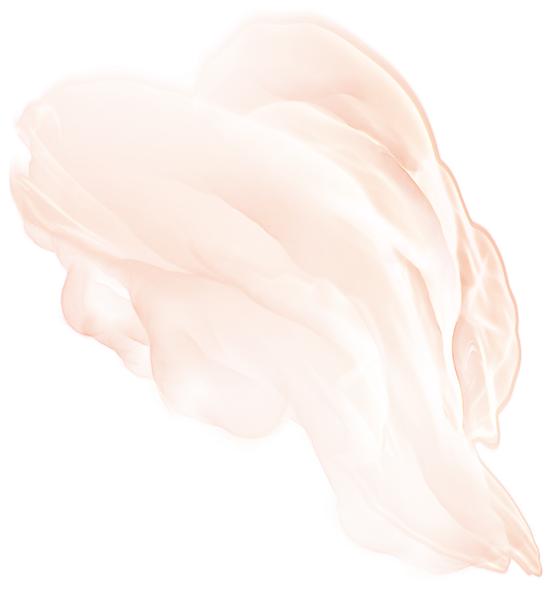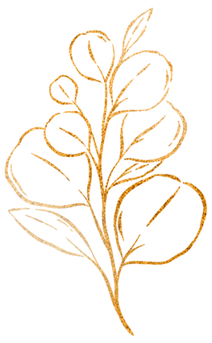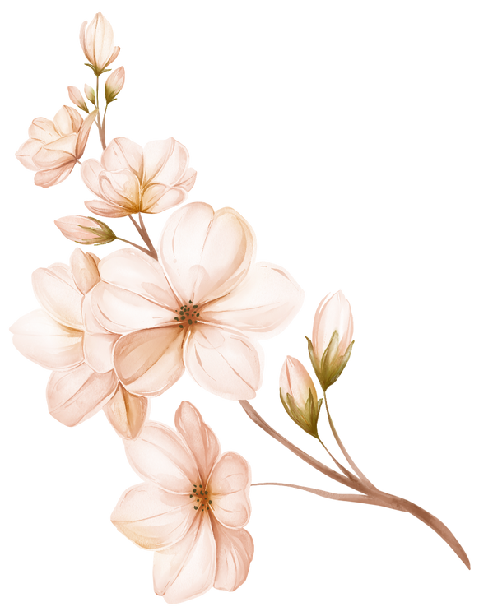

PLEASE

DO NOT

DISTURB

We are recovering from a long night partying with the newlyweds

DANIEL

OLIVIE

+



TO OUR FAMILY

AND FRIENDS

It means the world to us

to have you here.

Thank you for the support, encouragement, love, and laughter you have contributed to our lives.

We hope you enjoy this celebration and those we'll share for years to come.

DANIEL

OLIVIE

+



TO OUR FAMILY

AND FRIENDS

It means the world to us

to have you here.

Thank you for the support, encouragement, love, and laughter you have contributed to our lives.

We hope you enjoy this celebration and those we'll share for years to come.

DANIEL

OLIVIE

+

