

**DRINK**

* Diet Soda
* Regular Soda
* Ginger Ale
* Coffee
* Hot/Iced Tea
* Water
* Lemonade
* Juices
* Smoothies

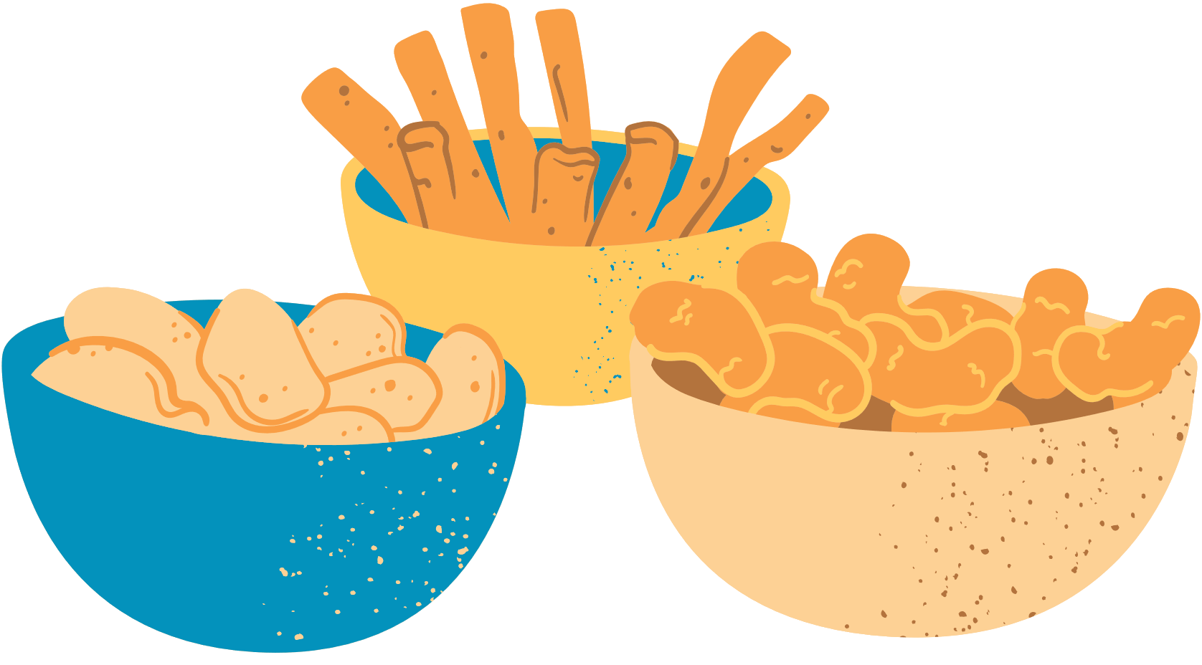

Room service

**SNACK**

* Popcorn
* Mixed Fruit
* Chocolate Kisses
* Potato Chips
* Pretzels
* Cookies
* Granola Bar
* Doritos
* KitKat
* Ice Cream

*Please choose the food and hang this outside your door before 4 pm. Deliveries will be made between 6-7 pm.*

