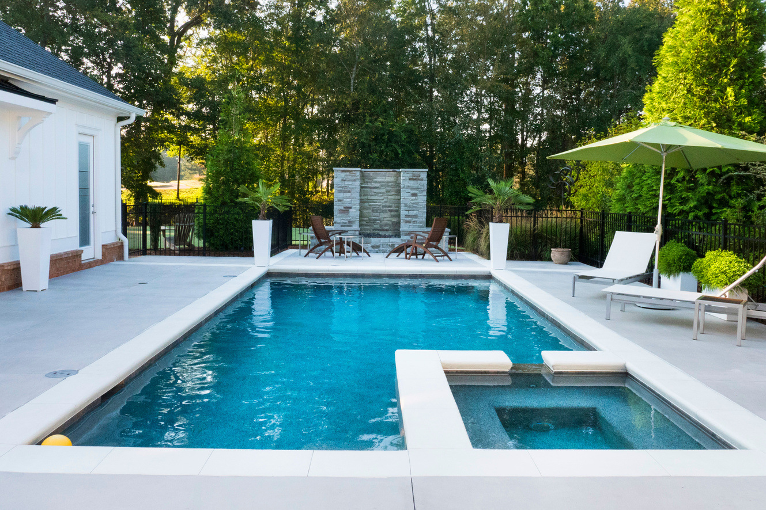

+1234-567-890

Call Now



POOL SERVICE

professional pool cleaning and repair

www. templateLAB.com

30%

OFF

COMPANY NAME



+1234-567-890

Call Now

www. templateLAB.com

* Destruction of algae and fungus;
* Removal of limescale;
* Disinfection;
* Deep cleaning of all surfaces of the bowl;
* Cleaning the joints and seams of the pool;
* Polishing of details from a stainless steel and the chrome plated surfaces.

OUR SERVICE

