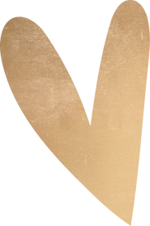

Happy

birthday,

Mom!

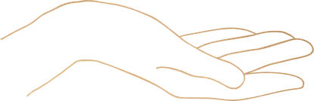

You have a unique gift in life, you manage to be both encouraging and annoying at the same time. It is difficult to balance the two, but you manage to make it look easy.

Happy birthday to my infuriating, lovable mom.

