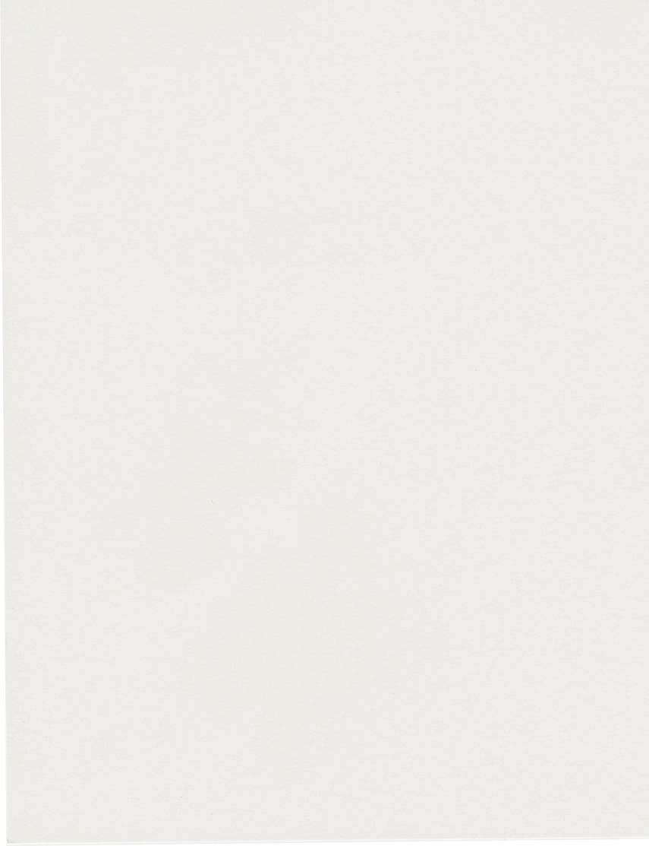

TO KIARA

Happy Birthday!

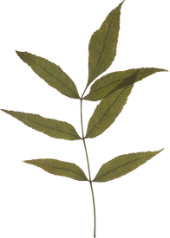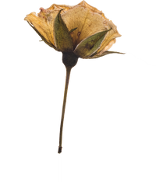

*You make each day special just by being yourself. I hope you’re enjoying your special day—may life continue to bring you the best days ahead.*