HAPPY

BIRTHDAY!

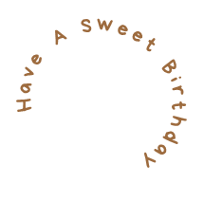

Birthdays are a new start,

a fresh beginning and

a time to pursue new endeavors with new goals. Move forward with confidence and courage. You are a very special person. May today and all of your days be amazing!

*- From Anna -*

