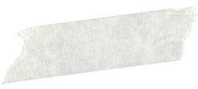

Happy

Birthday,

Dad!



Happiest birthday to the most generous and talented dad I have ever known! I always wanted to grow up to be like you, and you made me realize that this world is so wonderful.