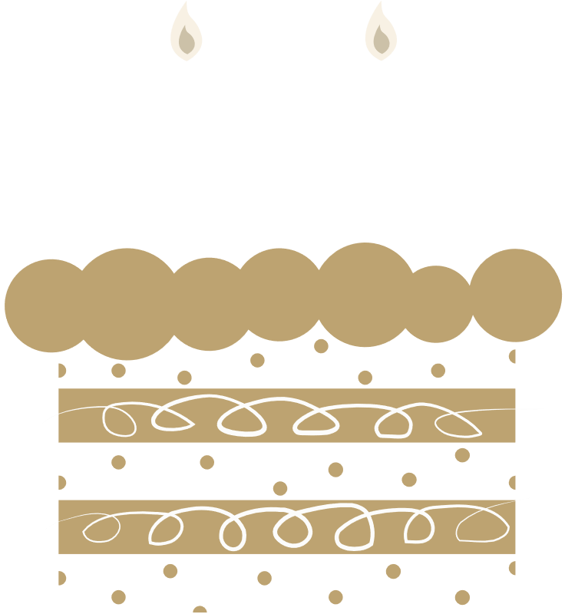

**HAPPY BIRTHDAY**

JUDY SMITH

You've got so much to look forward to in your 50s. In the words of Bob Hope: "I don't feel old. I don't feel anything until noon. That's when it's time for my nap".

