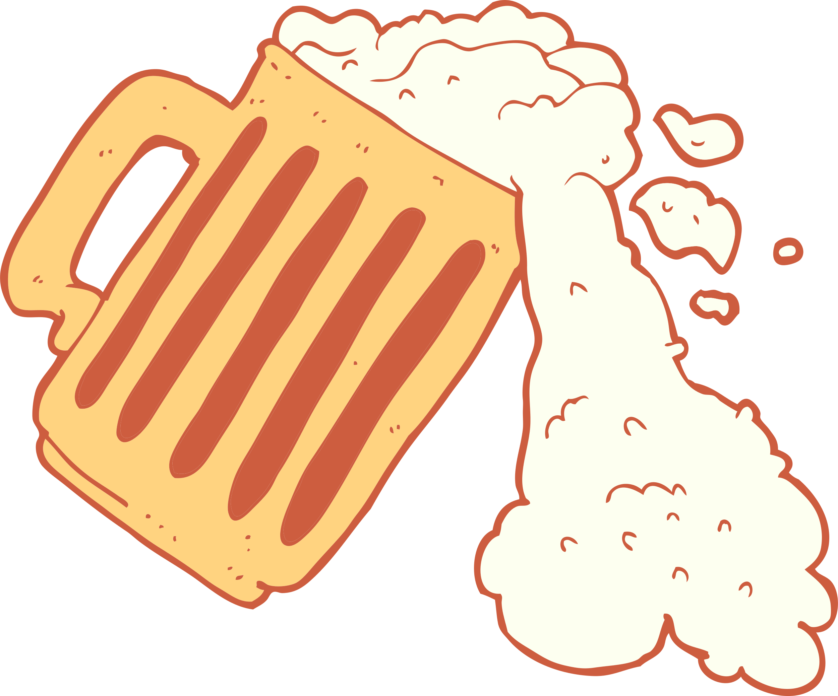

Happy

21st!

**08.08.2028**

**Cheers and beers for Tony**

